**University Catalog Management System Version 2.0**

Mentor:

Tim Downey

Team Members:

Jose Astudillo

Christopher Sutton

Senior Project

CIS 4911 – U01

Masoud Sadjadi

September 4th, 2014

Copyright © by Florida International University – Senior Project – UCMS Team

All rights reserved. No part of the University Catalog Management System Project or its documentation may be reproduced or transmitted in any form or by any means without prior written consent of the UCMS Team.

# Abstract

The Catalog Management System (CMS) project is designed to provide a way to manage electronically the content found inside the university catalogs. The system is sophisticated and highly user friendly in this aspect. For the second version of CMS, functionalities such as create, edit, propose, accept, and reject prospective catalogs which can become part of the university catalog once they are accepted by an Administrator will be implemented during this development cycle.. In addition, flowchart generation has been added in order to provide a better visualization of a degree path in a catalog.

This document contains information about the design of the entire project including the content added in this version (v 2.0) of the project. The main chapters on this document are the Introduction, System Design, and Detail Design. The introduction briefly defines the problem, the software development process used in this project, and terminology. The system design chapter provides information about the system decomposition, hardware and software mapping, persistent data management, and security/privacy. Furthermore, the detail design document has data about the static and dynamic models, and code specification. In addition, this document also contains glossary, appendix, and references.

Contents

Abstract 2

Introduction 4

Problem Definition 4

Design Methodology 4

Terminology 4

Definitions: 4

Acronyms and Abbreviations: 5

Overview of the System 5

System Design 7

Overview 7

Subsystem Decomposition 7

Hardware and Software Mapping 8

Persistent Data Management 9

Security / Privacy 13

Detail Design 15

Overview 15

Static Model 15

Dynamic Model 19

Code Specification 36

Glossary 42

Definitions: 42

Acronyms and Abbreviations: 42

Appendix 43

Appendix A – User Case Diagram (Use Cases being implemented) 43

Appendix B – User Cases being implemented 44

Appendix C – Documented Class Interfaces 66

Appendix D – Diary of meetings and tasks. 71

# Introduction

This chapter introduces the University Catalog Management System version 2.0 including the problem that this project is solving, the design methodology used in this project and the terminology that is used in this document.

## Problem Definition

Currently, having hard copies of university catalog makes it difficult for advisors to find out differences between programs of study, tracks of program, changes made in the requirements for a degree, etc. For this reason, the University Catalog Management System tries to simplify the work for advisors, so that they can help students faster.

In addition, the creation of new content for the catalog must be managed as well. Presently, this content can be added without passing any previous revision, which can really take a wrong direction if no previous check exists. Finally, the creation of path flows in a program are currently being generated manually, which is time consuming because it needs to be done for all programs in the catalog university.

## Design Methodology

The Catalog Management System has been developed using the Agile Software Development process. This process provides an adaptive planning, and evolutionary development of the system, which is broken down through different iterations. Furthermore, continuous improvement can be easily achieved, and changes can be adapted without making major changes within the system.

The main goal of this methodology is to facilitate early releases with minimal bugs at the end of iteration. In other words, the system can be developed until each functionality is implemented as the customer wants it; even when multiple changes have been required down the path of development.

## Terminology

Below is a list of the definitions and acronyms that are used throughout this document in explaining the catalog system.

### Definitions:

|  |  |
| --- | --- |
| **Administrator** | Registered user with credentials. User has elevated privileges and can give access to other users. |
| **Adviser** | Registered user with credentials. Adviser acts as a point of contact for students when they have questions with regards to their courses. |
| **Catalog** | Catalog is a publication issued by the university each year that documents all degrees offered and their courses required for graduation. |
| **Degree** | Associates, bachelors, masters, or doctorate level of education. We are focusing on undergraduate. |
| **Degree Granting Department** | A general governing body at FIU that is authorized to offer classes that teach the topics required for graduation with an undergraduate degree. |
| **Electives** | Courses that are not required by the degree program but allow students to explore additional interests within their major. |
| **Lead Adviser** | Registered user with credentials. Users will acts as administrators. |
| **Lower Division** | Lower division classes refers to a student’s first 60 credit hours |
| **Major** | A major is a student’s desired focus of study. |
| **Required** | Classes that are required for a specific degree program. |
| **Sciences** | Classes that are a focus on the core science topics such as physics. |
| **Student** | A student at FIU who can access the catalog systems to explore different degree paths. |
| **Upper Division** | Upper division classes refers to classes that are in the core of degree program. Typically they are the last 60 credit hours. |
| **User** | Any general person who uses the system |

### Acronyms and Abbreviations:

|  |  |
| --- | --- |
| **Admin** | Administrator |
| **CIS** | Computer and Information Sciences |
| **CSS** | Cascading Style Sheets |
| **DB** | Database |
| **DGU** | Degree Granting Unit |
| **FIU** | Florida International University |
| **GUI** | Graphical User Interface |
| **HTML** | Hypertext Markup Language |
| **JS** | JavaScript |
| **MVC** | Model View Controller |
| **PHP** | PHP: Hypertext Preprocessor |
| **SCIS** | School of Computer Information Sciences |
| **UCMS** | University Catalog Management System |
| **V2.0** | Version 2.0 |
| **Yii** | Yes it is Framework |

# Overview of the System

This document is organized as follow:

* Chapter 2 contains information about how the system is decomposed into subsystems, how software and hardware is mapped, how the data management is being achieved as well as its security and privacy.
  + Chapter 3 describes the design of the entire system. In addition, details of how the system work is shown by using static and dynamic models. Finally, it provides code specification, which describes attributes and methods being used as well as their constraints.
  + Chapter 4 gives a glossary of terms that were used throughout this document.
  + Chapter 5 is the appendix of the document.

# System Design

This chapter gives a high level description of the system design for the Catalog Management System. It starts by giving and overview of the system by describing the architectures used for this project. Then it explains how the system is decomposed in the different subsystems. Furthermore, it describes how hardware and software are mapped. It also addresses how data is management occurs. Finally, it explains how security and privacy is implemented.

## Overview

The Catalog Management System has been developed based on two architectures. The first one is Model-View-Controller (MVC) which works as the primary architectures. This architecture separates the representation of data (view), the logic of the system (controller), and the data itself (model).

The other is the Data Repository pattern. This pattern is used since all data is stored in a central database created for this project.

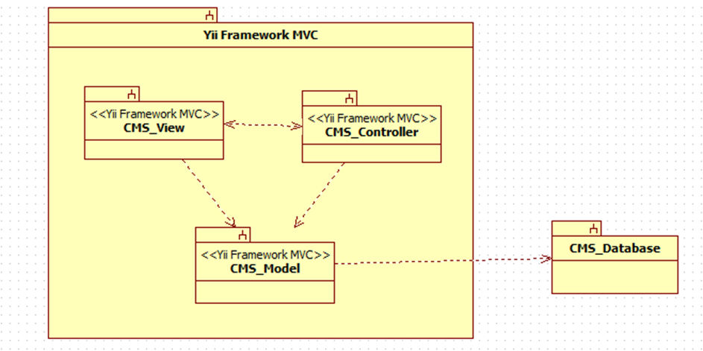

**Figure A:** Architecture

## Subsystem Decomposition

The Catalog Management System consists of four major subsystems, three inside Yii Framework MVC subsystem, and the other is the Repository subsystem.

* **CMS_View**

This subsystem has all forms that are presented to the user, so that he/she can interact with the system. In addition, this subsystem modifies what is being displayed based on the type of user that is currently interacting with the system. In this subsystem, the user can enter the requests that he/she needs to perform. Once the user has made a request the CMS_View subsystem interacts with the CMS_Controller to process this request.

* **CMS_Controller**

This subsystem has the logic of the system. Most of the data that is needed to be either displayed or stored goes through here. Furthermore, the CMS_Controller subsystem handles all commands received by the users in order to process their requests. Based on the request this controller will interact with the CMS_Model subsystem to either retrieve or store information in the database.

* **CMS_Model**

This subsystem provides a way to interact with the data so that it can be stored or retrieved from the repository. The CMS_Model subsystem receives commands from the CMS_Controller subsystem so that it can get or send information to the repository which contains all data for the system.

* **Repository**

This is the database where all information of the Catalog Management System is stored. Here is stored data for the users, catalogs, majors, minors, certificates, groups, set, and courses, among others. This subsystem is in direct contact with the CMS_Model subsystem. Once the CMS_Model sends a request the repository performs the action on the data.

Each subsystem is being used in all use cases that have been implemented on the Catalog Management System project.

## Hardware and Software Mapping

The Catalog Management System is hosted on a virtual machine provided by the School of Computing and Information Sciences. This VM runs on Windows 7. Furthermore, it is important to mention that the database “curriculum” is hosted by the SCIS as well. In addition the most current version of the code for the system is stored in the VM so that it can be accessed through the internet. In order to be accessible, the Apache server must be running all the time on the virtual machine. This server connects the code for the system with the database by using XAMPP.

On the other hand, the user can access the system using any PC that has an internet browser.

In order to better understanding of the hardware and software mapping for the Catalog Management System, a deployment diagram is provided below.

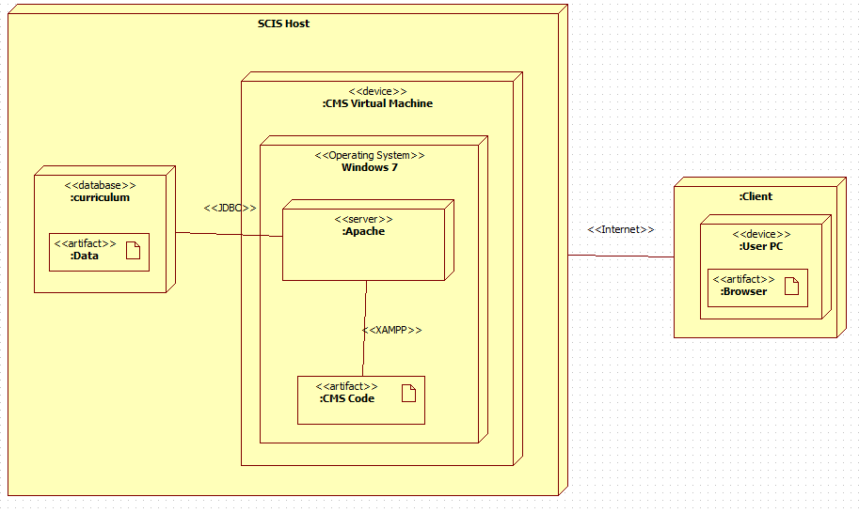

**Figure B:** SCIS Deployment

## Persistent Data Management

**User Information Storage**

The system requires storage of the information of the user that interacts with the system. Among the information about that is stored from the user is the last time he/she logged in into the system, the username, password, time when the user was created, the type of user he/she is, and whether this user is currently active or not.

**Catalog Storage**

The system requires storage of the different catalog that have been activated in the past, the ones that are proposed, the ones that are prospective, as well as the one that is currently active.

**Current Storage**

The system requires storage of the current data. This current data refers to the name, catalog id number, as well as the id for the majors, minors, certificates, tracks, groups, sets, and courses that are contained in the different catalogs of the system.

**History Storage**

The system requires storage of the current data. This history data refers to the description, identifier id number, which is the link to the current data, minimum number of credits, major number of credits, and in some cases notes for the majors, minors, certificates, tracks, groups, sets, and courses that are contained in the different catalogs of the system.

**Relation Storage**

The system requires storage of the relation that exists between majors and tracks, tracks and groups, minors and groups, certificates and groups, groups and sets, and finally sets and groups. This storage has as main purpose to save the relation between the groups mentioned above.



**Figure C:** Database table collection 1



**Figure D:** Database table collection 2



**Figure E:** Database table collection 3

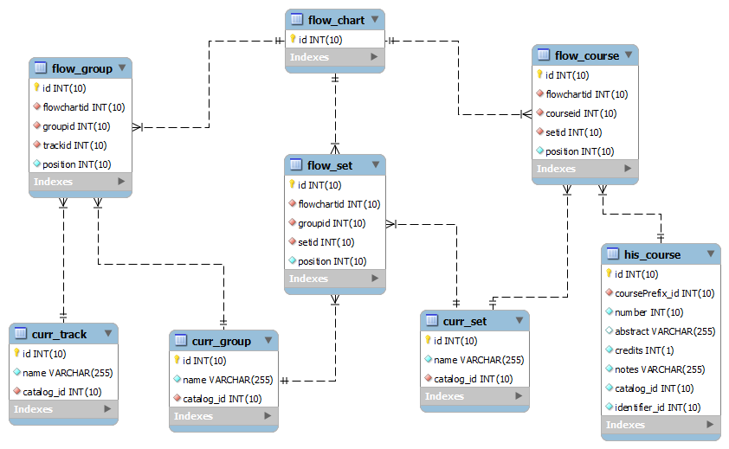

**Figure F:** Flowchart database tables

## Security / Privacy

**User authentication process**

The Catalog Management System has three main users: Administrator, Advisor, and regular visitor or student.

In the case of administrators and advisors, they need to log in with their credentials. On the main webpage of the system, users need to look for the log in button which is located at the end of the action bar (blue colored). Once the log in page is visible, user must provide their credentials, and the click in login, just pressed enter. The system will identify whether the user is administrator or advisor type, and provide them with their respective access to functionalities they can perform.

In the case of regular visitors or student, they are no required to log in to interact with the system. However, they do have access to a minim number of functionalities only.

**Encryption of data**

Currently, for data encryption, the CMS is using functions provided by Yii - framework. The “encrypting” function take the password the user inputs and converts it to a certain type of string that is composed of different characters, symbols, and digits. At the end the password that is stored in the database is complete changed to what the user entered.

**Use of firewalls and security servers**

The information held in the “curriculum” database is currently hosted by the School of Computing and Information Sciences (SCIS). This database can only be accessed when connecting directly to the “fiu-cis” network.

The latest version of the system is currently hosted by SCIS as well. This code is in a virtual machine that is directly connected to the “curriculum” database. This connection allows that users accessing to the system through the VM can access data stored in the main database.

# Detail Design

The Detail Design chapter gives a better understanding of the static and dynamic models for the Catalog Management System. The document describes the behavior and structure of each subsystem, the different classes along with their methods, and attributes that are part of the system. In addition a minimal class diagrams is provided to help understanding the relationship between classes, and the dynamic model of the system. Here, we can find the sequence diagrams for the use cases that are being implemented for the current version of the project. Main algorithms that have been used are included as well in this section. Finally, the document describes the class interfaces as well as the constraints for the main control object in each system.

## Overview

The Catalog Management System is basically composed of four subsystems, three of them fall inside the Yii MVC, and the other is the repository. This first subsystem is the controller which is in charge of controlling and processing all command within the system. Without this subsystem, the CMS would be just a bunch of forms and death data. The second subsystem is the view, which allows the user to interact with system. This subsystem makes possible that user can see and enter data to the repository. The third subsystem is the model, which allows the system to interact with the data stored in the database. This means to retrieve or send data to be stored. Finally, the last subsystem is the repository, which has the data for the system.

## Static Model

Here are provided minimal class diagrams for the CMS_Controller subsystem as well as the CMS_Model subsystem. Detailed class diagrams have not been provided in this document due to low visibility of methods, and fields.

CMS_Controller Subsystem

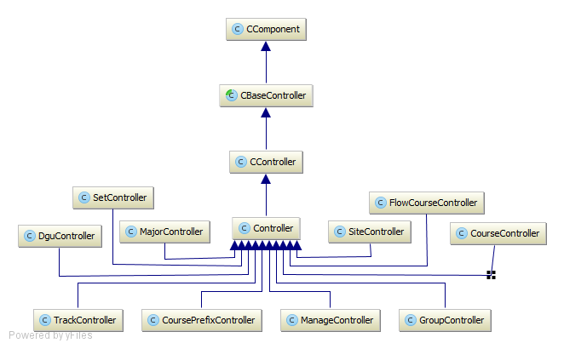

CMS_Model Subsystem

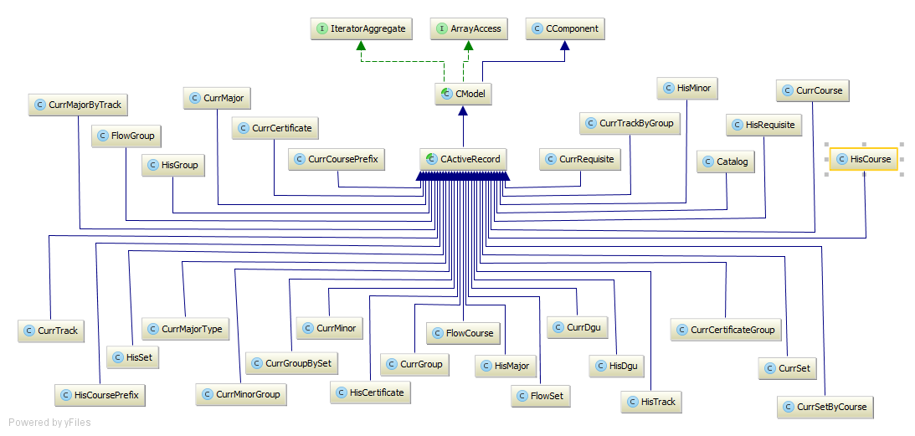

Prospective Catalog Subsystem

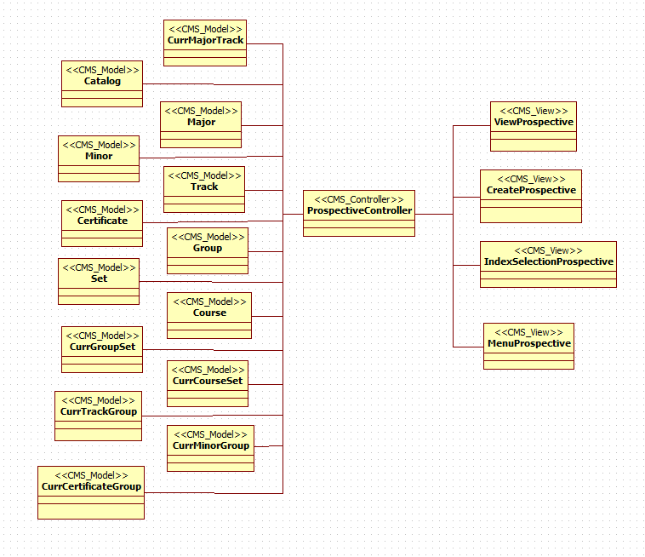

Flowchart subsystem

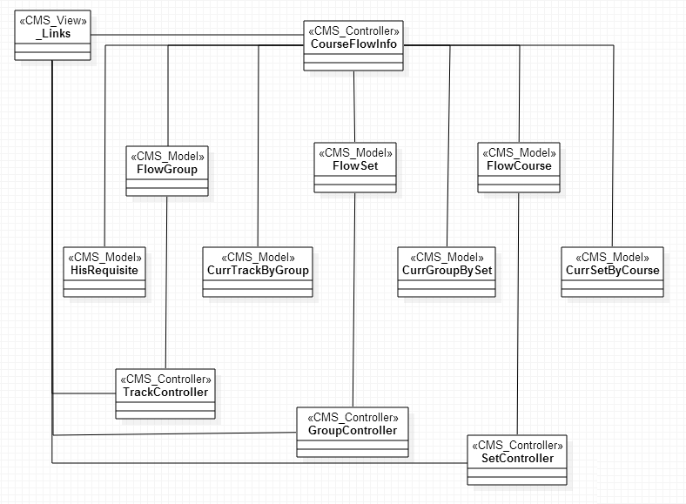

## Dynamic Model

Below are the sequence diagrams refined.

UCMSv2-0001: Create Prospective DGU Catalog

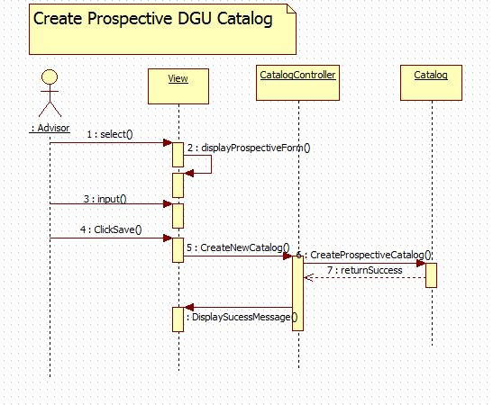

UCMSv2-0002: Propose Prospective DGU Catalog

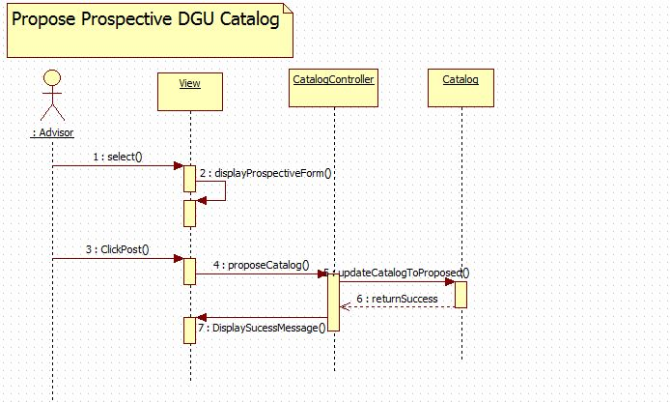

UCMSv2-0003 : Accept Prospective Catalog

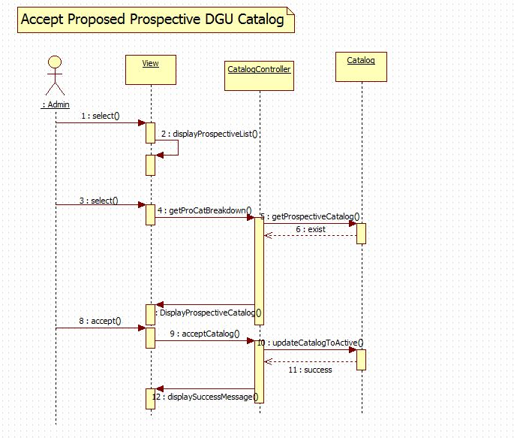

UCMSv2-0004 : Reject Prospective Catalog

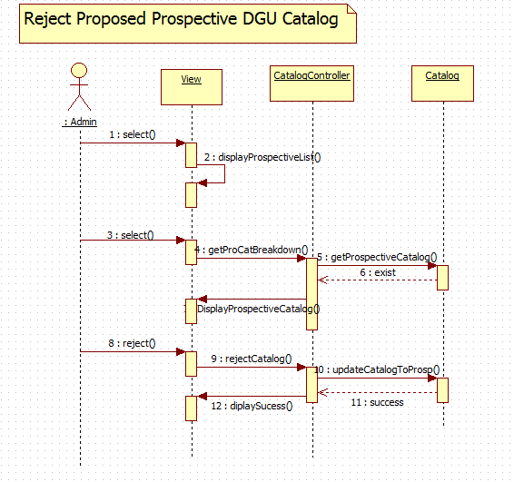

UCMSv2-0005 : View Prospective Catalog

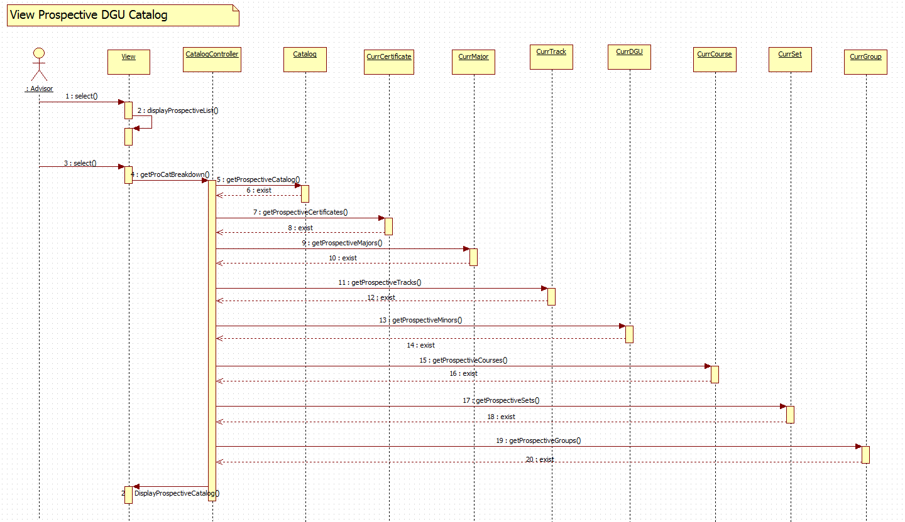

UCMSv2-0006 : View Track Flowchart (a)

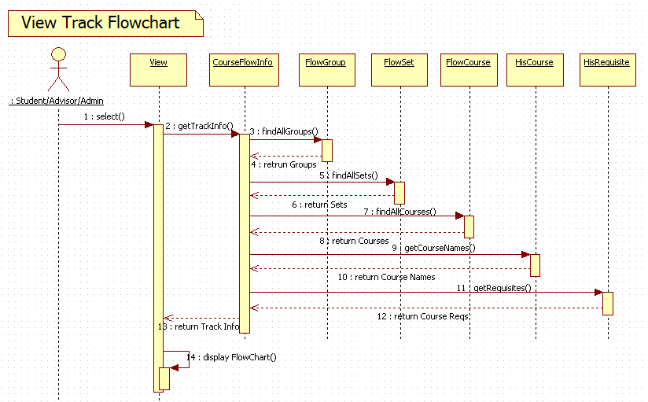

UCMSv2-0006 : View Track Flowchart (b)

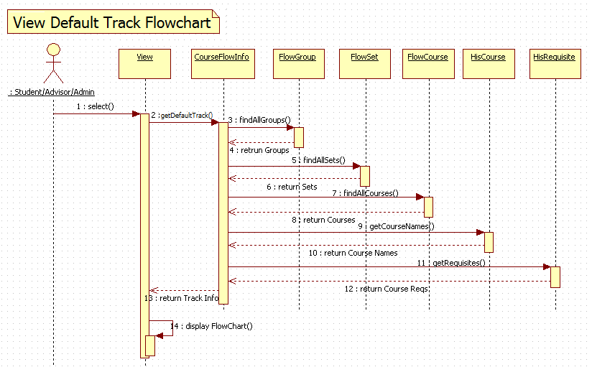

UCMSv2-0007 : View Group Flowchart (a)

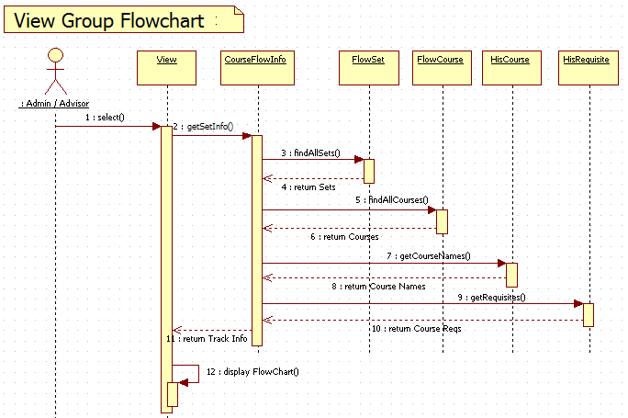

UCMSv2-0007 : View Group Flowchart (b)

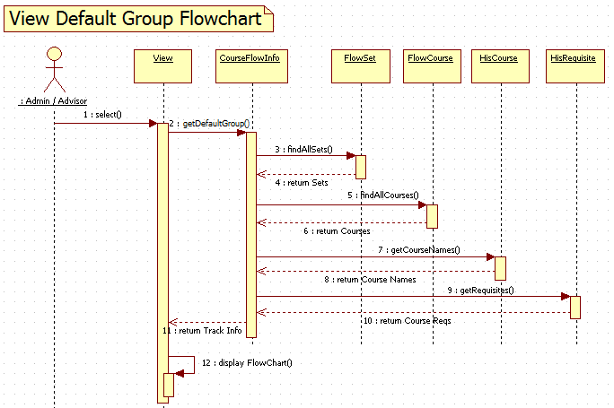

UCMSv2-0008 : View Set Flowchart (a)

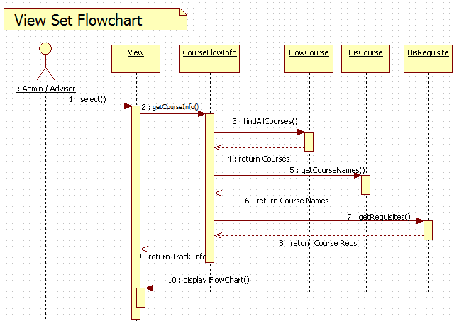

UCMSv2-0008 : View Set Flowchart (b)

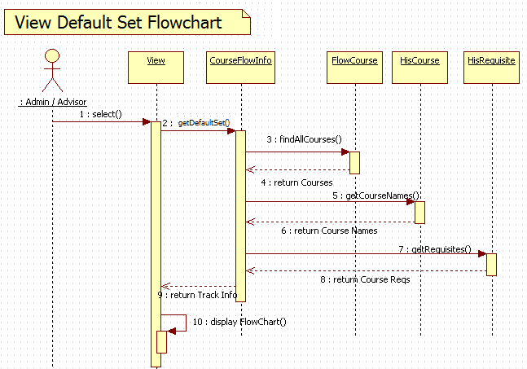

UCMSv2-0009 : Change Track Flowchart

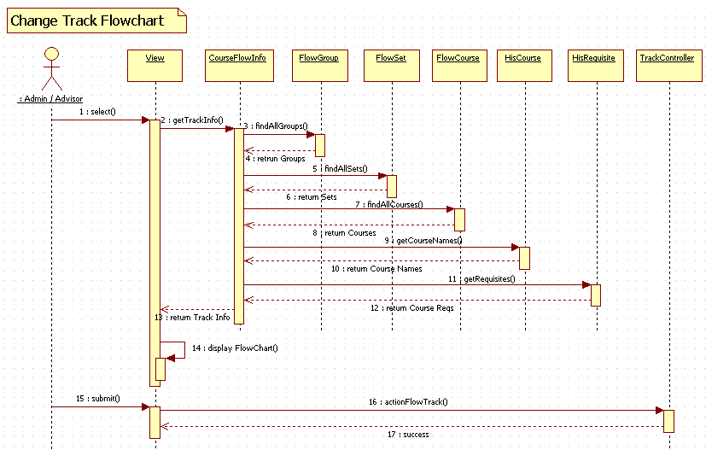

UCMSv2-0010 : Change Group Flowchart

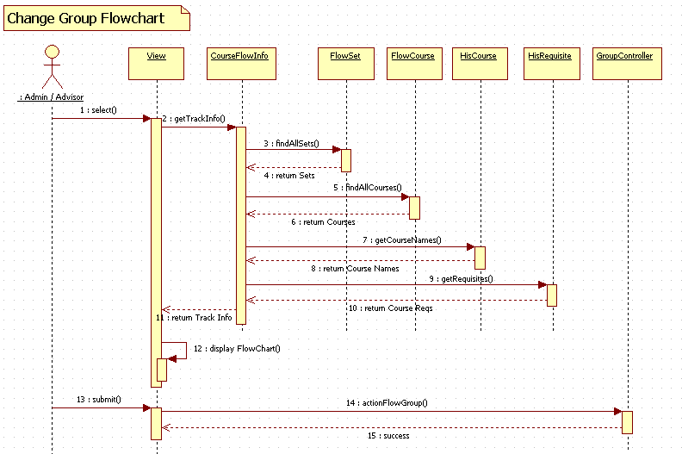

UCMSv2-0011 : Change Set Flowchart

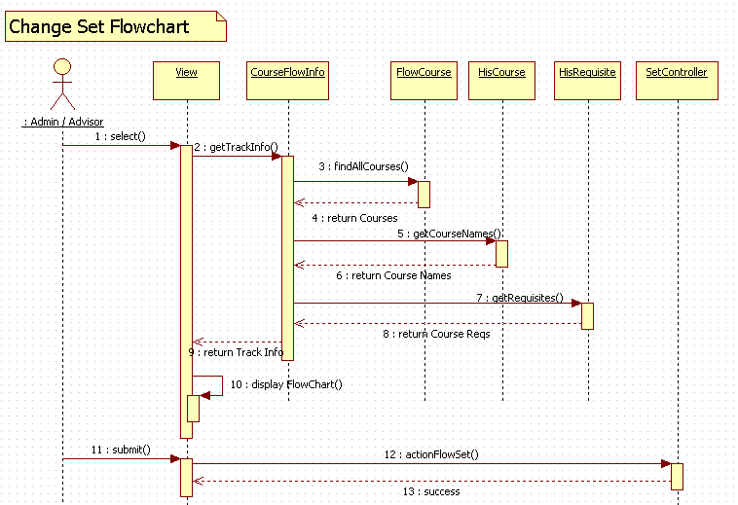

UCMSv2-0012 : Create Prospective Course

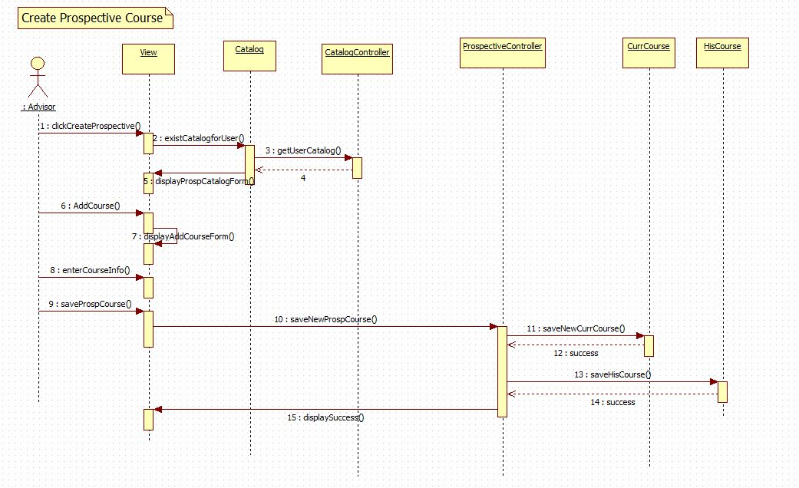

UCMSv2-0013 : Create Prospective Set

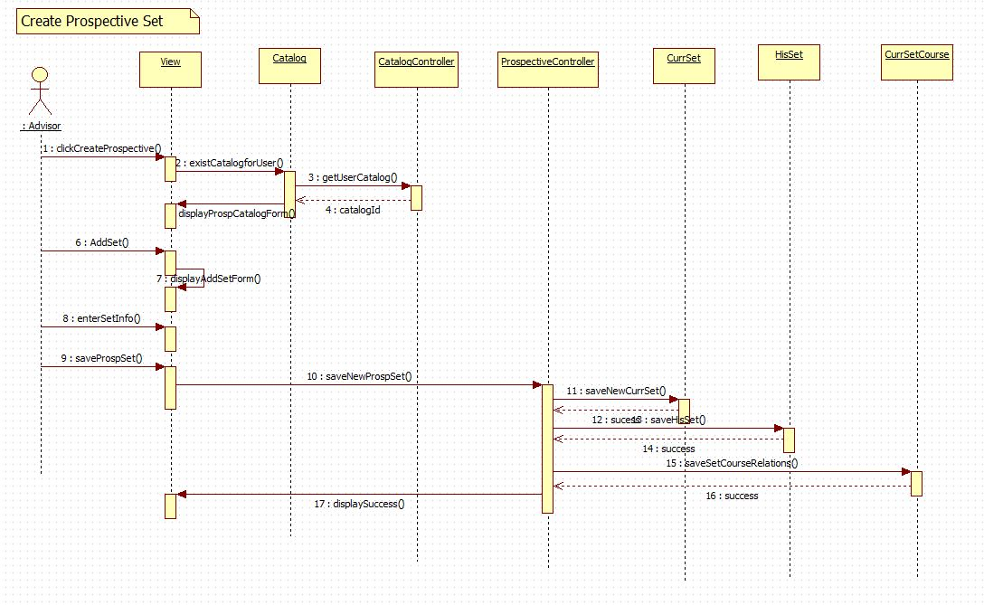

UCMSv2-0014 : Create Prospective Group

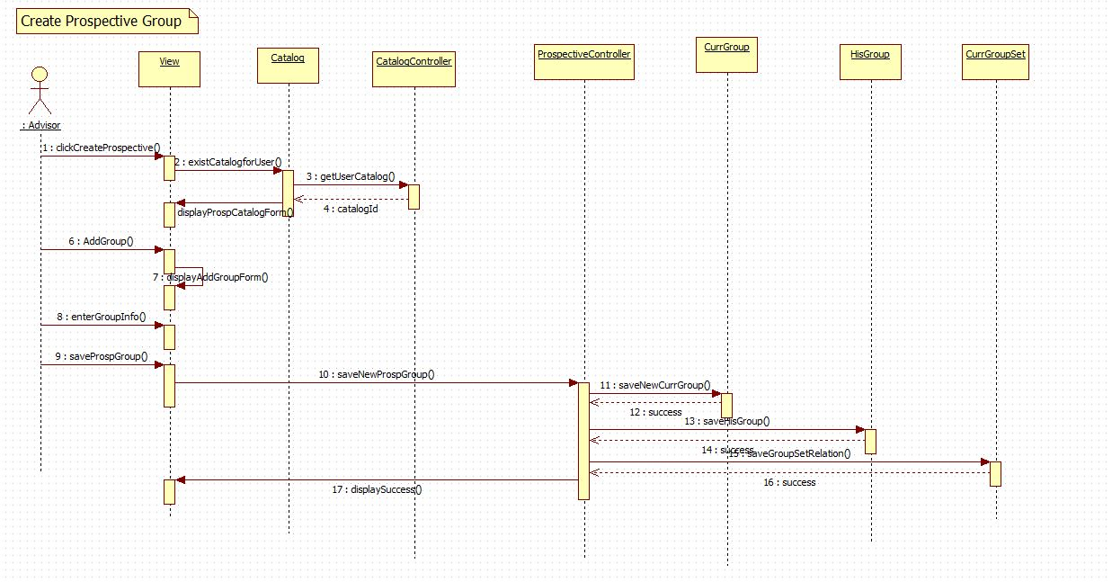

UCMSv2-0015 : Create Prospective Minor

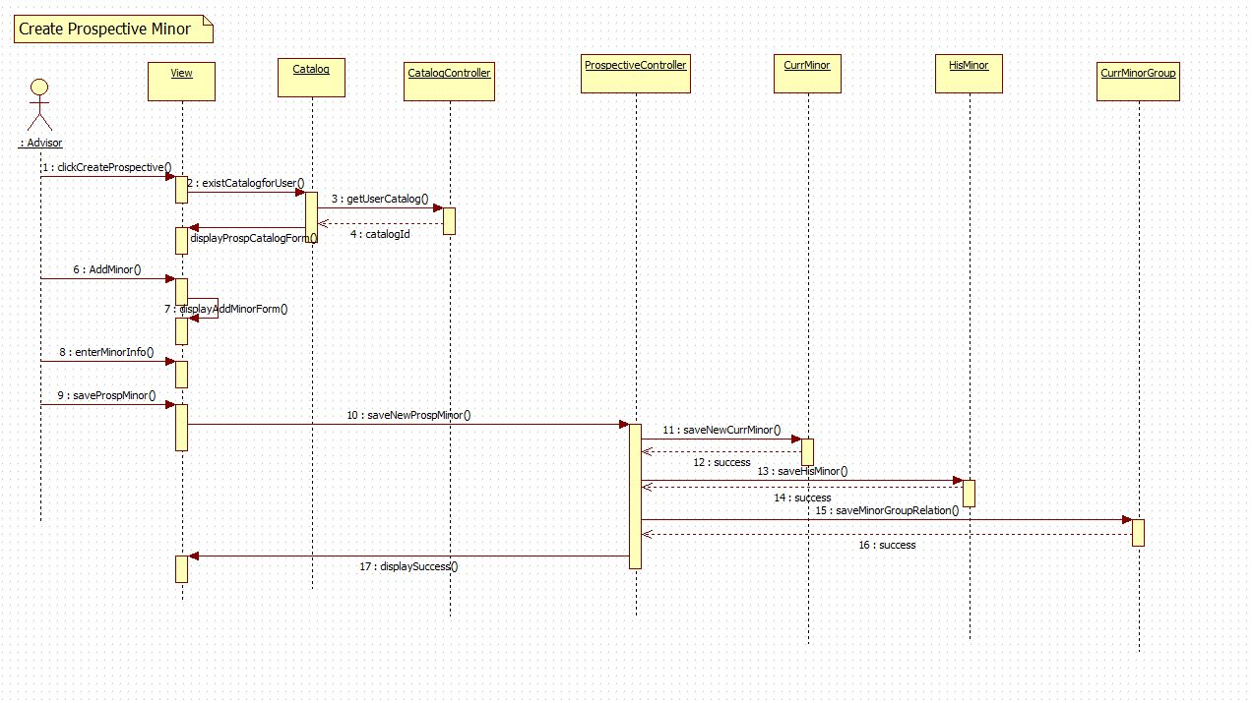

UCMSv2-0016 : Create Prospective Track

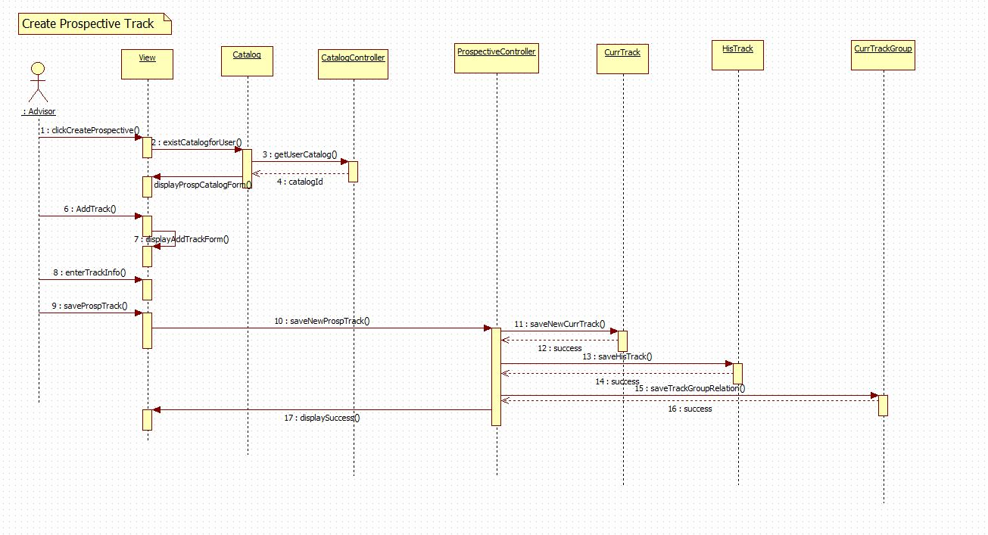

UCMSv2-0017: Create Prospective Certificate

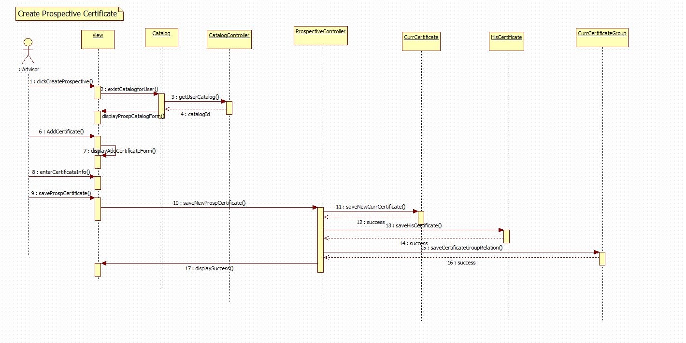

UCMSv2-0018 : Create Prospective Major

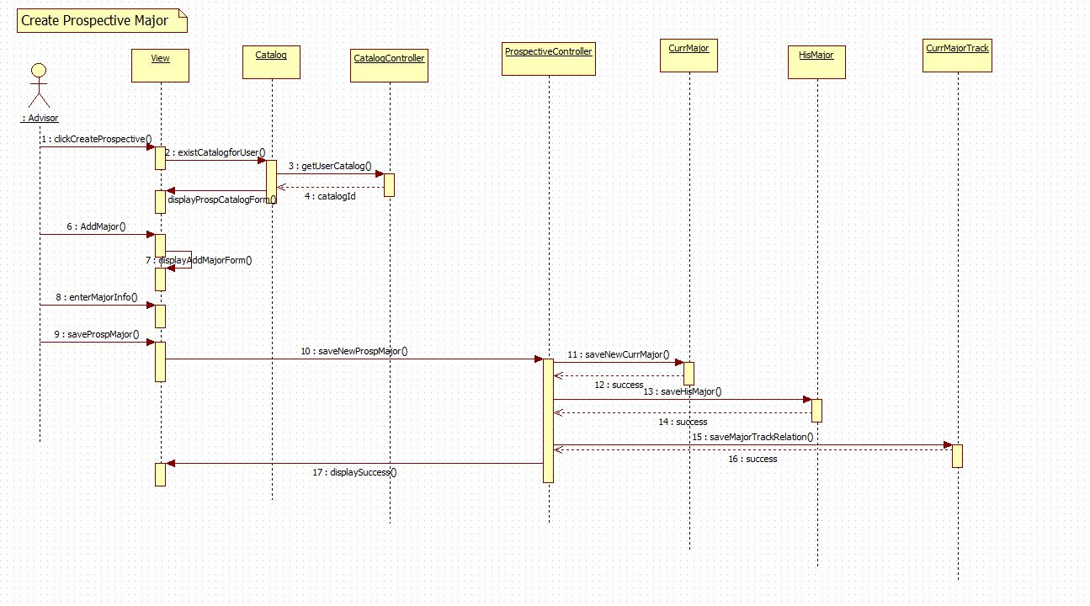

.

UCMSv2-0019 : Edit Prospective Course

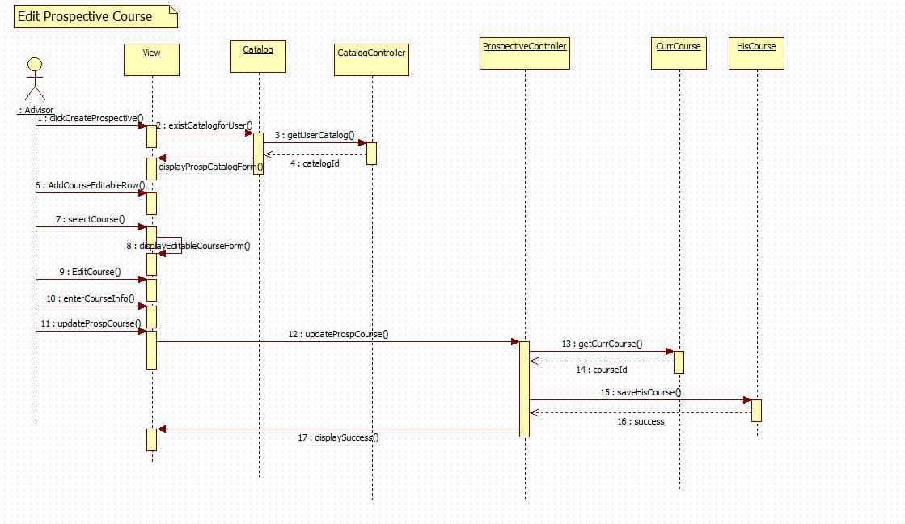

UCMSv2-0020 : Edit Prospective Set

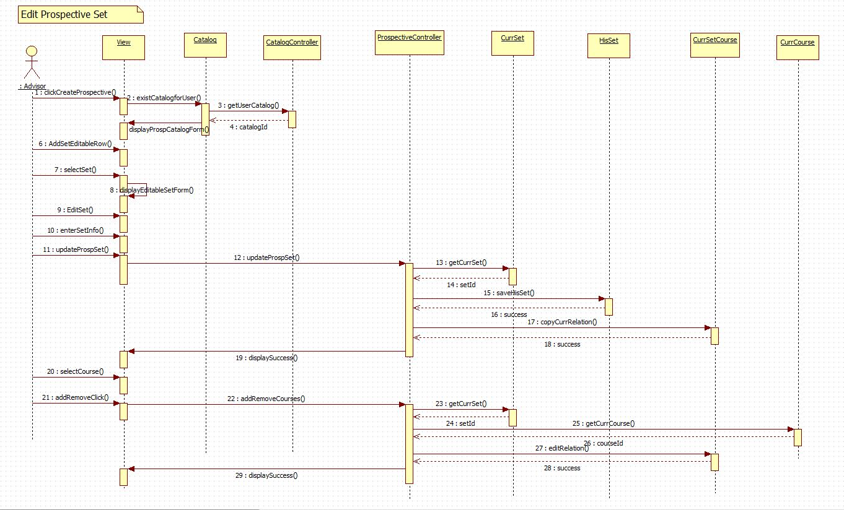

UCMSv2-0021 : Edit Prospective Group

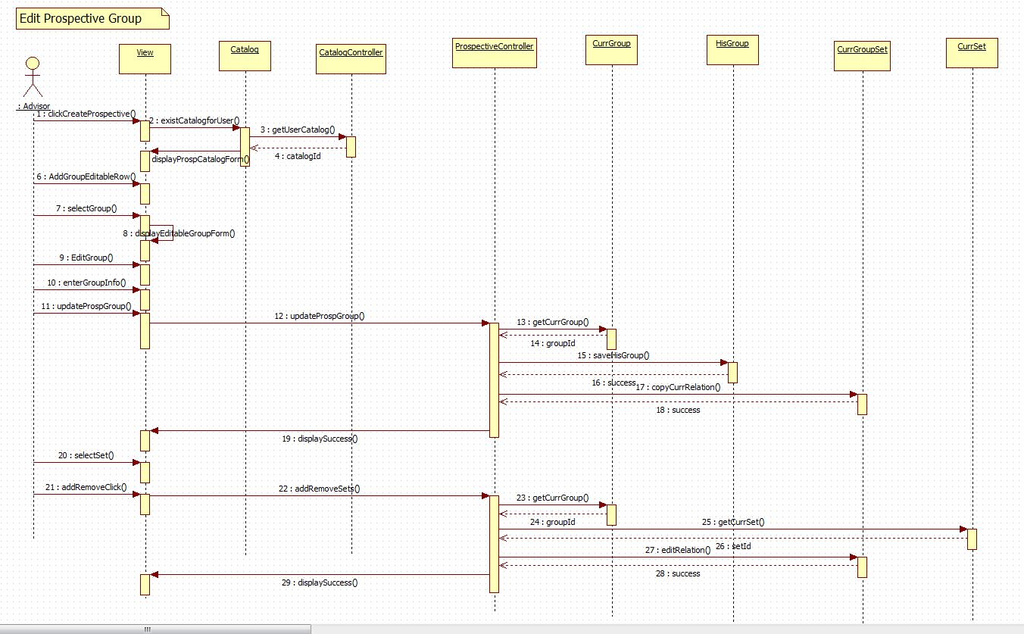

UCMSv2-0022 : Edit Prospective Minor

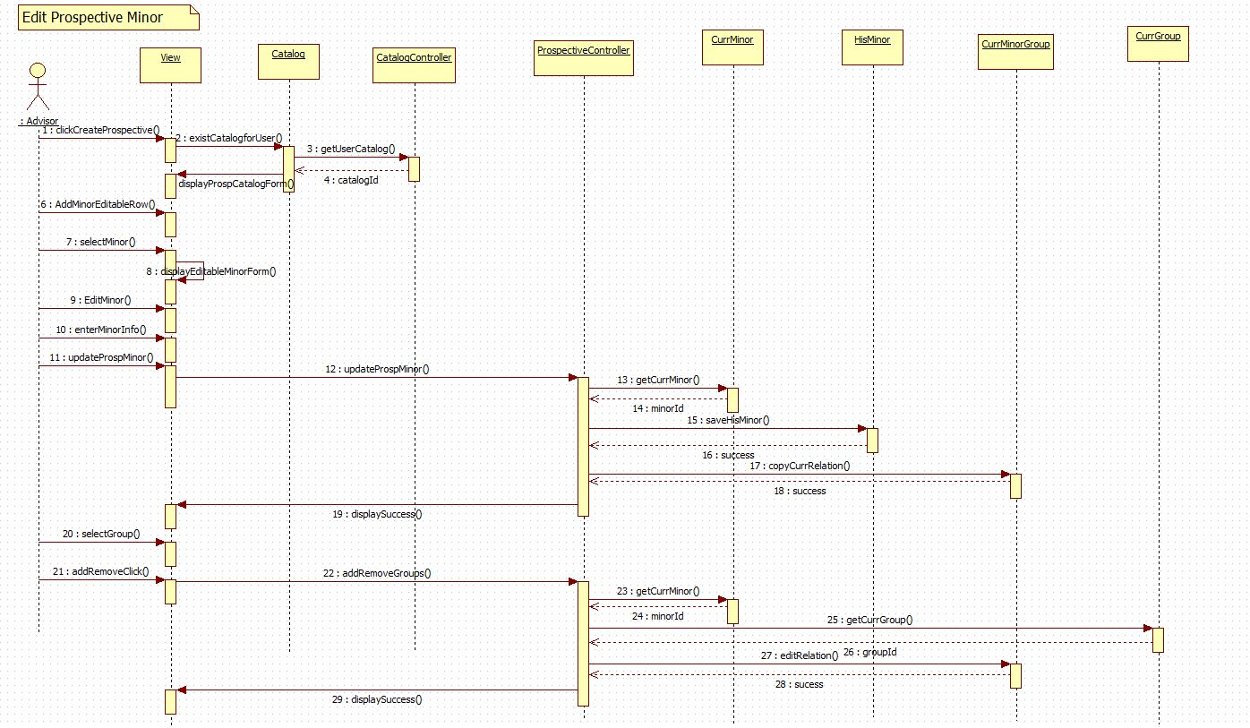

UCMSv2-0023 : Edit Prospective Track

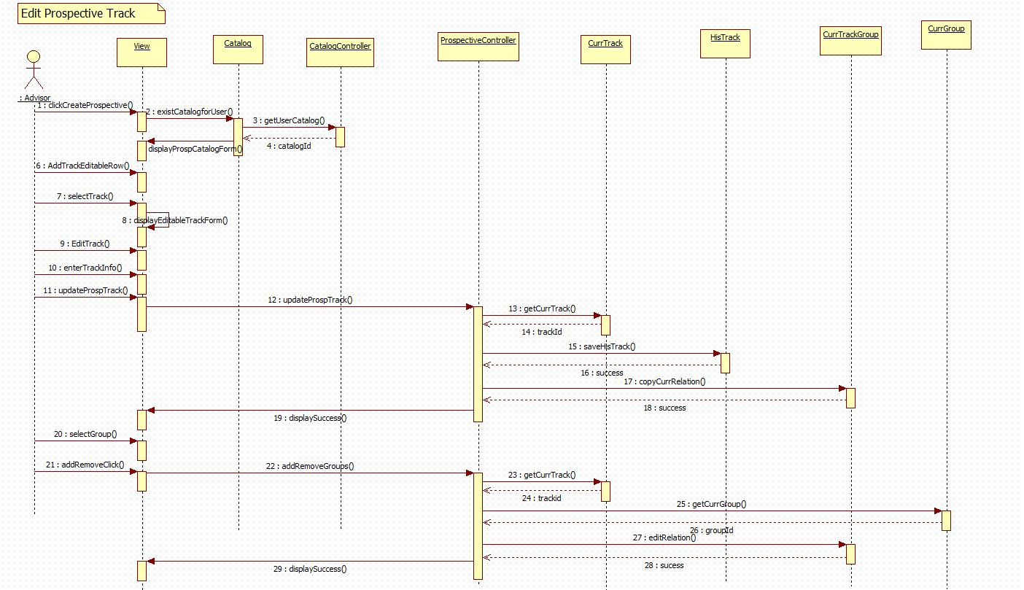

UCMSv2-0024 : Edit Prospective Certificate

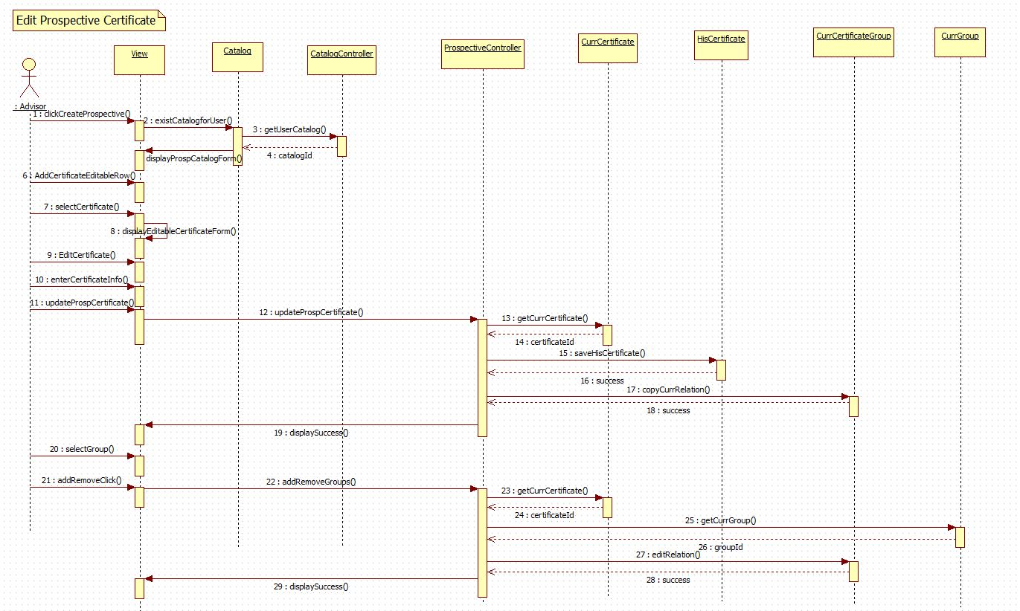

UCMSv2-0025 : Edit Prospective Major

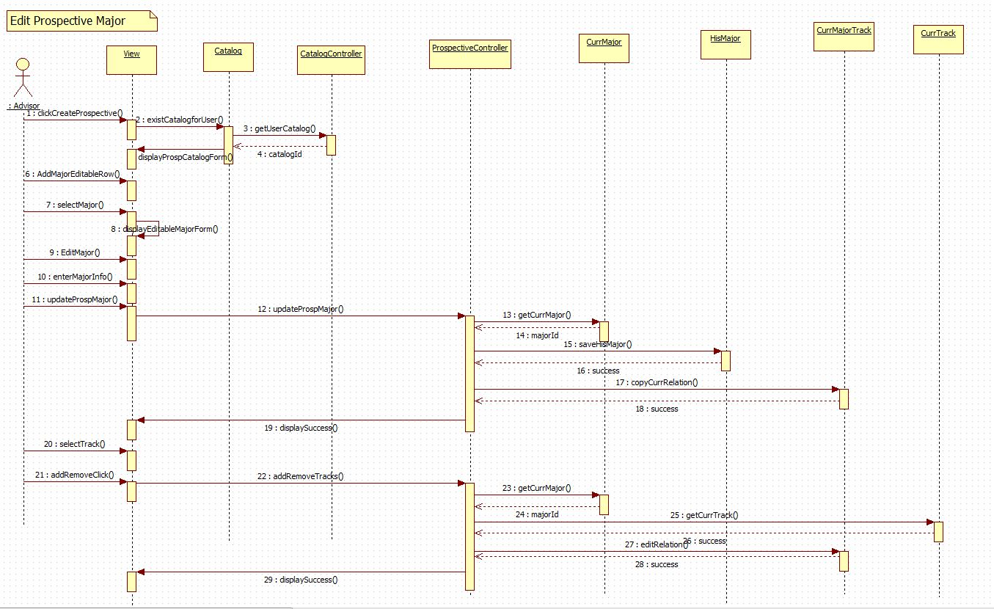

## Code Specification

In this section, a brief description for some of the methods that are part of the Catalog Management can be found. Additionally, pseudo-code for the flowchart view is provided.

**Methods used for the prospective catalog creation:**

These methods can be found in the prospectiveCatalogController.php

* InsertNewCatalog(): this methods insert a new row in the catalog table so that an advisor can make propose changes under this catalog. This method receives information entered for his/her catalog, and then it creates an instance of the catalog model and the saves the data into the catalog table.
* LoadProspectiveCatalogInfo(): this method gets data from the catalog table and displays it for the user that belongs the catalog to.
* ProposeProspectiveCatalog(): this methods sets the isPropose field on the catalog table so that the administrator user can see it in the list to be reviewed.
* AcceptProspectiveCatalog(): this method accepts the catalogs that a user has proposed. This occurs by setting the activated field to 1 and setting to 0 the isProspecive and isProposed field in the catalog table.
* RejectProspectiveCatalog(): this method rejects the catalogs that a user has proposed. This occurs by setting to 1 the isProspecive and to 0 isProposed field in the catalog table for the users catalog.
* SaveNewMajor(): this method receives data that the user entered on the createProspectiveMajorForm. Then creates instances of the CurrMajor, HisMajor, and CurrMajorByTrack modesl. After these instantiations, it checks whether the major already exists, so that it can insert information in all tables. Similar methods are SaveNewMinor(), SaveNewCertificates(), SaveNewTrack(), SaveNewGroup(), and SaveNewSet().These methods interact in same manner with interaction of their current Curr, His, and Relation models.
* UpdateMajor(): this method receives data that user entered in the editProspectiveMajorForm. Then saves the information in the HisMajor table by using the HisMajor models. After this, it copies all existing relation on the CurrMajorByTrack table with the current last active catalog; however, it copies with the catalog id that the user has created. This same mechanism works for UpdateMinor(), UpdateCertificate(), UpdateTrack(), UpdateGroup(), and UpdateSet(). These methods perform same action with the difference that they interact with their respective relation models.
* RetrieveMajorField(): this methods sends back information of major that the user has selected to edit, and therefore propose changes for it. Similar methods are RetrieveMinorFields(),RetrieveTrackFields(),RetrieveCertificateFields(),RetrieveGroupFields(),RetrieveSetFields(), and RetrieveCourseFields().

**Methods used in the flowchart generation:**

The following methods can be found in SetController.php.

* actionFlowSet(): Called after a user has made changes to the format of the Set flowchart model. It first parses the necessary information retrieved via POST in order to make changes to a courses position within the Course display.

The following methods can be found in the GroupController.php.

* actionFlowGroup(): Called after a user has made changes to the format of the Group flowchart model. It first parses the necessary information retrieved via POST in order to make changes to a sets position within the Set display.

The following methods can be found in the TrackController.php.

* actionFlowTrack(): Called after a user has made changes to the format of the Track flowchart model. It first parses the necessary information retrieved via POST in order to make changes to a groups position within the Group display.

The following methods can be found in the CourseFlowInfo.php.

* getCourseInfo(): Accepts an array of courses within a particular set. The function iterates through the array building a string representation of the course. It returns an array containing course information and course ids.
* getSetinfo():When a flowchart does exist for a particular group this function creates a view of the sets using the group id as the input parameter. Returns an array containing course information respective to its saved position, set ids, a set index, and the respective flowchart id. This function relies on finding the position for each element in the flowchart database.
* getTrackInfo():When a flowchart does exist for a particular track this function creates a view of the groups using the track id as the input parameter. Returns an array containing course information respective to its saved position, group ids, a set index and group index, and the respective flowchart id. This function relies on finding the position for each element in the flowchart database.
* getDefaultSet(): When a flowchart does not exist for a particular set this function creates a default view of the courses using the set id as the input parameter. Returns an array containing course information and course ids.
* getDefaultGroup(): When a flowchart does not exist for a particular group this function creates a default view of the sets and courses using the group id as the input parameter. It returns an array of sets that include courses, in addition to set id’s, and the number of sets.
* getDefaultTrack(): When a flowchart does not exist for a particular track this function creates a default view of the groups, sets and courses using the track id as the input parameter. It returns an array of groups that include sets and courses, in addition to groupd id’s, group index and a set index.
* getRequisites(): Accepts an array of courses. Using these courses it iterates through the set and determines what courses have pre-requisites. It then orders the list of courses by the number of pre-requisites the course has in ascending order.

The following methods can be found in the flowchartdrag.js file.

* Box(id, dropState): Initializes three variables based on the parameters passed. Initiaizes the id of the Box as well as the current state, or dropState. The variable value is set to empty.
* allowDrop(obj, ev): Tests to see whether or not the box, or obj, can be dropped in a specific location, ev.
* drag(parent, ev): Acknowledges the box, or parent, is being dragged in a certain environment, ev.
* drop(dropTarget, ev): Ensures that a box can be dropped in a specific location. Inside this function is where the key updates to the metadata is made based on position, flowchart id, and either course, group, or track id.
* dragStart(obj): Changes the boxes border to show that it is being moved to a new location in addition to updating the object source and changing the dragging flag.
* dragEnd(obj): Signifies the end of dragging a specific object by changing the destination border to red and updating field canDrop to true and the isDragging flag to false.

Pseudo-code for flowcharts generation:

The flowchart visualization can be displayed using two different algorithms:

* 1. If a flowchart for that particular track, group, or set already exists in the database the information will be retrieved from this source.
     1. Track view:
        + 1. Using the track ID and find all groups inside that particular track.
          2. Get each group ID and find all sets inside that group.
          3. Get each set ID inside each group and find the courses inside the sets.
          4. Now place each course information inside an array based on the group’s position, the sets positions, and finally the courses position.
     2. Group view:
        1. Using the group ID find all sets inside that group.
        2. Get each set ID inside each group and find the courses inside the sets.
        3. Now place each course information inside an array based on the sets positions, and finally the courses position.
     3. Set view:
        1. Using the set ID find the courses inside the set.
        2. Now place each course information inside an array based on the courses position.
  2. If a flowchart does not exists we create a standard or default view for the track, group, or set. The information is pulled using the curriculum database.
  3. Track view:
  4. Using the track ID and find all groups inside that particular track.
  5. Get each group ID and find all sets inside that group.
  6. Get each set ID inside each group and find the courses inside the sets.
  7. Apply the requisites algorithm on the set of courses to order the course set in ascending order based on the number of pre-requisites each course has.
     1. Iterate through the list of courses while comparing each course to the number of pre-requisites it has by retrieving information from the his_requisites table.
  8. Now place each course information inside an array based on the group id, set id, and the course order. The group id and set id are placed in ascending order.
  9. Group view:
  10. Using the group ID find all sets inside that group.
  11. Get each set ID inside each group and find the courses inside the sets.
  12. Apply the requisites algorithm on the set of courses to order the course set in ascending order based on the number of pre-requisites each course has.
      1. Iterate through the list of courses while comparing each course to the number of pre-requisites it has by retrieving information from the his_requisites table.
  13. Now place each course information inside an array based on the set id and the course order. The set id are placed in ascending order.
  14. Set view:

1. Using the set ID find the courses inside the sets.
2. Apply the requisites algorithm on the set of courses to order the course set in ascending order based on the number of pre-requisites each course has. Iterate through the list of courses while comparing each course to the number of pre-requisites it has by retrieving information from the his_requisites table.
3. Now place each course information inside an array based on the course order.

# Glossary

### Definitions:

|  |  |
| --- | --- |
| **Administrator** | Registered user with credentials. User has elevated privileges and can give access to other users. |
| **Adviser** | Registered user with credentials. Adviser acts as a point of contact for students when they have questions with regards to their courses. |
| **Catalog** | Catalog is a publication issued by the university each year that documents all degrees offered and their courses required for graduation. |
| **Degree** | Associates, bachelors, masters, or doctorate level of education. We are focusing on undergraduate. |
| **Degree Granting Department** | A general governing body at FIU that is authorized to offer classes that teach the topics required for graduation with an undergraduate degree. |
| **Electives** | Courses that are not required by the degree program but allow students to explore additional interests within their major. |
| **Lead Adviser** | Registered user with credentials. Users will acts as administrators. |
| **Lower Division** | Lower division classes refers to a student’s first 60 credit hours |
| **Major** | A major is a student’s desired focus of study. |
| **Required** | Classes that are required for a specific degree program. |
| **Sciences** | Classes that are a focus on the core science topics such as physics. |
| **Student** | A student at FIU who can access the catalog systems to explore different degree paths. |
| **Upper Division** | Upper division classes refers to classes that are in the core of degree program. Typically they are the last 60 credit hours. |
| **User** | Any general person who uses the system |

### Acronyms and Abbreviations:

|  |  |
| --- | --- |
| **Admin** | Administrator |
| **CIS** | Computer and Information Sciences |
| **CSS** | Cascading Style Sheets |
| **DB** | Database |
| **DGU** | Degree Granting Unit |
| **FIU** | Florida International University |
| **GUI** | Graphical User Interface |
| **HTML** | Hypertext Markup Language |
| **JS** | JavaScript |
| **MVC** | Model View Controller |
| **PHP** | PHP: Hypertext Preprocessor |
| **SCIS** | School of Computer Information Sciences |
| **UCMS** | University Catalog Management System |
| **V2.0** | Version 2.0 |
| **Yii** | Yes it is Framework |

# Appendix

## Appendix A – User Case Diagram (Use Cases being implemented)

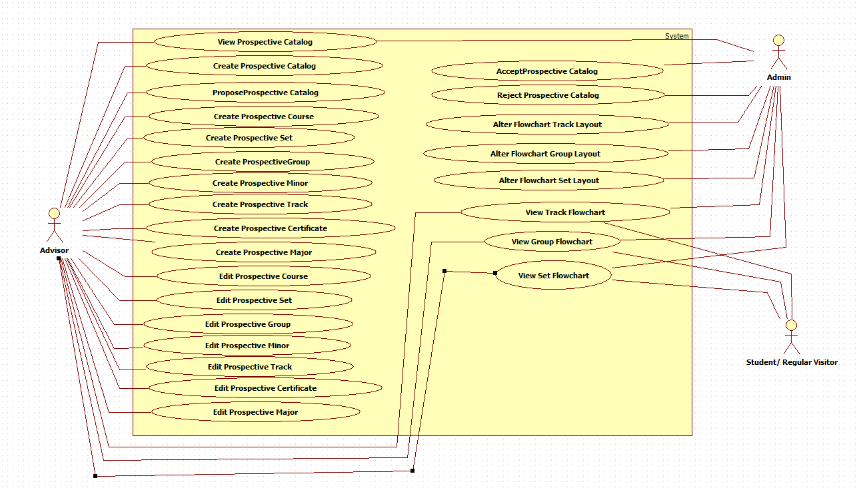

## Appendix B – User Cases being implemented

**Use Case ID :** UCMSv2 – 0001

**Name :** Create DGU Proposed Catalog

**Details :** This use case allows Admin and advisor to create prospective new catalogs for their corresponding DGU. This includes prospective courses, major, minor, certificates, tracks, groups and set.

**Actors :** Admin, and advisor.

**Pre-condition(s):**

1. Advisor must be logged in into the system

**Description :**

1. Use case begins when Advisor clicks on the “Prospective Catalog” button.
2. Use select option “Create Prospective Catalog” from the prospective catalog page.
3. User must select his/her DGU.
4. User must enter catalog name.
5. User must enter description for the catalog.
6. User must enter term in which catalog will be activated.
7. User must enter the year catalog will be activated.
8. Use Case ends when user clicks in “Create New Catalog” button.

**Post condition(s):**

1. Prospective catalog must be saved in the database.

=====================================================================

**Use Case ID :** UCMSv2 – 0002

**Name :** Propose DGU Catalog.

**Details :** This use case allows Advisors to post a prospective catalog for their corresponding DGU.

**Actors :** Advisor

**Pre-condition(s):**

1. Advisor must be logged in into the system.
2. A DGU Prospective Catalog must have been already created.

**Description :**

1. Use case begins when Admin or Advisor clicks on the “Prospective Catalog” button.
2. Use select option “View Prospective Catalog” from the prospective catalog page.
3. System must display the prospective catalog.
4. Use case ends when user clicks on “Propose” button.

**Post condition(s):**

1. DGU Admin must be able to see the proposed prospective catalog.

=====================================================================

**Use Case ID :** UCMSv2 – 0003

**Name :** Accept Prospective Catalog.

**Details :** This use case allows Admin to accept prospective catalogs that have been proposed.

**Actors :** Admin

**Pre-condition(s):**

1. Advisor must be logged in into the system.
2. A DGU Prospective Catalog must have been proposed already.

**Description :**

1. Use case begins when Admin or Advisor clicks on the “Prospective Catalog” button.
2. Use select option “View Prospective Catalog” from the prospective catalog page.
3. System must display the list of proposed prospective catalogs.
4. Admin must select the prospective catalog that he/she wants to review.
5. System must display the prospective catalog
6. Admin must click the button “Accept.”

**Post condition(s):**

1. Status of the prospective catalog must change in the database.
2. The prospective catalog that was rejected must appear in the list with a status of accepted.

=====================================================================

**Use Case ID :** UCMSv2 – 0004

**Name :** Reject Prospective Catalog

**Details :** This use case allows Admin to reject prospective catalogs that have been proposed.

**Actors :** Admin

**Pre-condition(s):**

1. Advisor must be logged in into the system.
2. A DGU Prospective Catalog must have been proposed already.

**Description :**

1. Use case begins when Admin or Advisor clicks on the “Prospective Catalog” button.
2. Use select option “View Prospective Catalog” from the prospective catalog page.
3. System must display the list of proposed prospective catalogs.
4. Admin must select the prospective catalog that he/she wants to review.
5. System must display the prospective catalog
6. Admin must click the button “Reject.”

**Post condition(s):**

1. Status of the prospective catalog must change in the database.
2. The prospective catalog that was rejected must appear in the list with a status of rejected.

=====================================================================

**Use Case ID :** UCMSv2 – 0005

**Name :** View Prospective Catalog.

**Details :** This use case allows Admin to see the prospective catalogs that have been proposed by either advisors or admin itself

**Actors :** Admin

**Pre-condition(s):**

1. Admin must be logged in into the system.

**Description :**

1. Use case begins when Admin or Advisor clicks on the “Prospective Catalog” button.
2. Admin selects option “View Prospective Catalogs” from the prospective catalog page.
3. System must display the list of proposed prospective catalogs.
4. Admin must select the prospective catalog that he/she wants to review.
5. Use case end when system displays the prospective catalog that Admin has selected.

**Post condition(s):** None

=====================================================================

**Use Case ID :** UCMSv2 – 0006

**Name :** View Track Flowchart.

**Details :** This use case allows users to view the track flowchart for a particular degree.

**Actors :** Users, Admins, Super Admins

**Pre-condition(s):**

1. User must select some degree.

**Description :**

1. Once the users have selected a degree track they will then be able to see the courses associated with that major.
2. In order to view the flow chart a user would have to click the “View Flowchart” button.
3. The flowchart would then be loaded divided by:
   1. Major track
      1. Groups
      2. Sets
      3. Courses
4. The flowchart components will be positioned in the same view that it was last saved in.
5. Clicking on the group will display the flowchart for that particular group. See UCMSv2- 0007.

**Post condition(s):** None

**Alternative Course of Action:** If no flowchart exists in the database a default flowchart will be built. See sequence diagram UCMSv2 – 0006(b).

=====================================================================

**Use Case ID :** UCMSv2 – 0007

**Name :** View Group Flowchart.

**Details :** This use case allows users to view the group flowchart for a particular degree.

**Actors :** Users, Admins, Super Admins

**Pre-condition(s):**

1. User must select some degree.

**Description :**

1. Once the users have selected a degree track they will then be able to see the courses associated with that major.
2. In order to view the flow chart a user would have to click the “View Flowchart” button.
3. In order to navigate to the group level click on any group inside the track flowchart.
4. The flowchart would then be loaded divided by:
   1. Major group:
      1. Sets
      2. Courses
5. The flowchart components will be positioned in the same view that it was last saved in.
6. Clicking on the set will display the flowchart for that particular set. See UCMSv2-0008.

**Post condition(s):** None

**Alternative Course of Action:** If no flowchart exists in the database a default flowchart will be built. See sequence diagram UCMSv2 – 0007(b).

=====================================================================

**Use Case ID :** UCMSv2 – 0008

**Name :** View Set Flowchart.

**Details :** This use case allows users to view the set flowchart for a particular degree.

**Actors :** Users, Admins, Super Admins

**Pre-condition(s):**

1. User must select some degree.

**Description :**

1. Once the users have selected a degree track they will then be able to see the courses associated with that major.
2. In order to view the flow chart a user would have to click the “View Flowchart” button.
3. In order to navigate to the group level click on any group inside the track flowchart, and then click on any set.
4. The flowchart would then be loaded divided by:
   1. Major set:
      1. Courses
5. The flowchart components will be positioned in the same view that it was last saved in.
6. Clicking on the course will display detailed course information for that particular course.

**Post condition(s):** None

**Alternative Course of Action:** If no flowchart exists in the database a default flowchart will be built. See sequence diagram UCMSv2 – 0008(b).

=====================================================================

**Use Case ID :** UCMSv2 – 0009

**Name :** Alter Flowchart Track Layout.

**Details :** This use case allows users to alter layout of the flowchart for a particular track.

**Actors :** Admin

**Pre-condition(s):**

1. User must select some degree.

**Description :**

1. Once the users have selected a degree track they will then be able to see the courses associated with that major.
2. By navigating to the track layout for the flowchart a user will see a visualization organized by groups.
3. Users can move these groups to different positions if they wish to alter their order.
4. Once the user has finished making the position changes, clicking submit will write these changes to the database.

**Post condition(s):** None

=====================================================================

**Use Case ID :** UCMSv2 – 0010

**Name :** Alter Flowchart Group Layout.

**Details :** This use case allows users to alter layout of the flowchart for a particular group.

**Actors :** Admin

**Pre-condition(s):**

1. User must select some degree.

**Description :**

1. Once the users have selected a degree track they will then be able to see the courses associated with that major.
2. By navigating to the group layout for the flowchart a user will see a visualization organized by sets.
3. Users can move these sets to different positions if they wish to alter their order.
4. Once the user has finished making the position changes, clicking submit will write these changes to the database.

**Post condition(s):** None

=====================================================================

**Use Case ID :** UCMSv2 – 0011

**Name :** Alter Flowchart Set Layout.

**Details :** This use case allows users to alter layout of the flowchart for a particular set.

**Actors :** Admin

**Pre-condition(s):**

1. User must select some degree.

**Description :**

1. Once the users have selected a degree track they will then be able to see the courses associated with that major.
2. By navigating to the set layout for the flowchart a user will see a visualization organized by courses.
3. Users can move these courses to different positions if they wish to alter their order.
4. Once the user has finished making the position changes, clicking submit will write these changes to the database.

**Post condition(s):** None

=====================================================================

**Use Case ID :** UCMSv2 – 0012

**Name :** Create Prospective Course

**Details :** This use case allows Advisor to create prospective course for the prospective catalog he/she is working on.

**Actors :** Advisor

**Pre-condition(s):**

1. Advisor must be logged in into the system.
2. A DGU Prospective Catalog must have been created already.

**Description :**

1. Use case begins when Advisor click on “Create Prospective Catalog.”
2. User clicks the “+” button in the Add courses section.
3. User must enter name for the new course.
4. User must click in the “Add” button.
5. System must display the “create prospective course” form.
6. User must enter the prefix, code, number of credits, description, and notes for the course being added.
7. Use case ends when user click on “Save” button.

**Post condition(s):**

1. A new prospective course must have been created.

=====================================================================

**Use Case ID :** UCMSv2 – 0013

**Name :** Create Prospective Set

**Details :** This use case allows Advisor to create prospective set for the prospective catalog he/she is working on.

**Actors :** Advisor

**Pre-condition(s):**

1. Advisor must be logged in into the system.
2. A DGU Prospective Catalog must have been created already.

**Description :**

1. Use case begins when Advisor click on “Create Prospective Catalog.”
2. User clicks the “+” button in the Add set section.
3. User must enter name for the new set.
4. User must click in the “Add” button.
5. System must display the “create prospective set” form.
6. User must enter the description, minimum number of credits, and the maximum number of credits for the set being added.
7. User must select the course to be added in the new set.
8. Use case ends when user click on “Save” button.

**Post condition(s):**

1. A new prospective set must have been created.

=====================================================================

**Use Case ID :** UCMSv2 – 0014

**Name :** Create Prospective Group

**Details :** This use case allows Advisor to create prospective group for the prospective catalog he/she is working on.

**Actors :** Advisor

**Pre-condition(s):**

1. Advisor must be logged in into the system.
2. A DGU Prospective Catalog must have been created already.

**Description :**

1. Use case begins when Advisor click on “Create Prospective Catalog.”
2. User clicks the “+” button in the Add group section.
3. User must enter name for the new group.
4. User must click in the “Add” button.
5. System must display the “create prospective group” form.
6. User must enter the description, minimum number of credits, and the maximum number of credits for the group being added.
7. User must select the sets to be added in the new group.
8. Use case ends when user click on “Save” button.

**Post condition(s):**

1. A new prospective group must have been created.

=====================================================================

**Use Case ID :** UCMSv2 – 0015

**Name :** Create Prospective Minor

**Details :** This use case allows Advisor to create prospective minor for the prospective catalog he/she is working on.

**Actors :** Advisor

**Pre-condition(s):**

1. Advisor must be logged in into the system.
2. A DGU Prospective Catalog must have been created already.

**Description :**

1. Use case begins when Advisor click on “Create Prospective Catalog.”
2. User clicks the “+” button in the Add minor section.
3. User must enter name for the new minor.
4. User must click in the “Add” button.
5. System must display the “create prospective minor” form.
6. User must enter the description, and the minimum number of credits for the minor being added.
7. User must select the groups to be added in the new minor.
8. Use case ends when user click on “Save” button.

**Post condition(s):**

1. A new prospective minor must have been created.

=====================================================================

**Use Case ID :** UCMSv2 – 0016

**Name :** Create Prospective Track

**Details :** This use case allows Advisor to create prospective track for the prospective catalog he/she is working on.

**Actors :** Advisor

**Pre-condition(s):**

1. Advisor must be logged in into the system.
2. A DGU Prospective Catalog must have been created already.

**Description :**

1. Use case begins when Advisor click on “Create Prospective Catalog.”
2. User clicks the “+” button in the Add track section.
3. User must enter name for the new track.
4. User must click in the “Add” button.
5. System must display the “create prospective track” form.
6. User must enter the description, and the minimum number of credits for the track being added.
7. User must select the groups to be added in the new track.
8. Use case ends when user click on “Save” button.

**Post condition(s):**

1. A new prospective track must have been created.

=====================================================================

**Use Case ID :** UCMSv2 – 0017

**Name :** Create Prospective Certificate

**Details :** This use case allows Advisor to create prospective certificate for the prospective catalog he/she is working on.

**Actors :** Advisor

**Pre-condition(s):**

1. Advisor must be logged in into the system.
2. A DGU Prospective Catalog must have been created already.

**Description :**

1. Use case begins when Advisor click on “Create Prospective Catalog.”
2. User clicks the “+” button in the Add certificate section.
3. User must enter name for the new certificate.
4. User must click in the “Add” button.
5. System must display the “create prospective certificate” form.
6. User must enter the description, and the minimum number of credits for the certificate being added.
7. User must select the groups to be added in the new certificate.
8. Use case ends when user click on “Save” button.

**Post condition(s):**

1. A new prospective certificate must have been created.

=====================================================================

**Use Case ID :** UCMSv2 – 0018

**Name :** Create Prospective Major

**Details :** This use case allows Advisor to create prospective major for the prospective catalog he/she is working on.

**Actors :** Advisor

**Pre-condition(s):**

1. Advisor must be logged in into the system.
2. A DGU Prospective Catalog must have been created already.

**Description :**

1. Use case begins when Advisor click on “Create Prospective Catalog.”
2. User clicks the “+” button in the Add major section.
3. User must enter name for the new major.
4. User must click in the “Add” button.
5. System must display the “create prospective major” form.
6. User must enter the description for the major set being added.
7. User must select the tracks to be added in the new major.
8. Use case ends when user click on “Save” button.

**Post condition(s):**

1. A new prospective major must have been created.

=====================================================================

**Use Case ID :** UCMSv2 – 0019

**Name :** Edit Prospective Course

**Details :** This use case allows Advisor to make prospective change to a course for the prospective catalog he/she is working on.

**Actors :** Advisor

**Pre-condition(s):**

1. Advisor must be logged in into the system.
2. A DGU Prospective Catalog must have been created already.
3. A course must exist.

**Description :**

1. Use case begins when Advisor click on “Create Prospective Catalog.”
2. User clicks the “+edit” button in the Add courses section.
3. User must select course to be edited.
4. System must display the “prospective course” form with all field filled out with the current information.
5. User must enter changes to the prefix, code, number of credits, description, and notes for the course being edited.
6. Use case ends when user click on “Save” button.

**Post condition(s):**

1. Changes to the course must been saved in the database.

=====================================================================

**Use Case ID :** UCMSv2 – 0020

**Name :** Edit Prospective Set

**Details :** This use case allows Advisor to make prospective change to a set for the prospective catalog he/she is working on.

**Actors :** Advisor

**Pre-condition(s):**

1. Advisor must be logged in into the system.
2. A DGU Prospective Catalog must have been created already.
3. A set must exist.

**Description :**

1. Use case begins when Advisor click on “Create Prospective Catalog.”
2. User clicks the “+edit” button in the Add set section.
3. User must select set to be edited.
4. System must display the “prospective set” form with all field filled out with the current information.
5. User must enter changes to the minimum number of credits, description, and the maximum number of credits for the set being edited.
6. User must click on “Save” button.
7. User has the option to either add course or remove course to the set he/she is editing by clicking either on the “Add Course” or “Remove Course” button.

**Post condition(s):**

1. Changes to the set must been saved in the database.

=====================================================================

**Use Case ID :** UCMSv2 – 0021

**Name :** Edit Prospective Group

**Details :** This use case allows Advisor to make prospective change to a group for the prospective catalog he/she is working on.

**Actors :** Advisor

**Pre-condition(s):**

1. Advisor must be logged in into the system.
2. A DGU Prospective Catalog must have been created already.
3. A group must exist.

**Description :**

1. Use case begins when Advisor click on “Create Prospective Catalog.”
2. User clicks the “+edit” button in the Add group section.
3. User must select group to be edited.
4. System must display the “prospective group” form with all field filled out with the current information.
5. User must enter changes to the minimum number of credits, description, and the maximum number of credits for the group being edited.
6. User must click on “Save” button.
7. User has the option to either add set or remove set to the group he/she is editing by clicking either on the “Add Set” or “Remove Set” button.

**Post condition(s):**

1. Changes to the group must been saved in the database.

=====================================================================

**Use Case ID :** UCMSv2 – 0022

**Name :** Edit Prospective Minor

**Details :** This use case allows Advisor to make prospective change to a minor for the prospective catalog he/she is working on.

**Actors :** Advisor

**Pre-condition(s):**

1. Advisor must be logged in into the system.
2. A DGU Prospective Catalog must have been created already.
3. A minor must exist.

**Description :**

1. Use case begins when Advisor click on “Create Prospective Catalog.”
2. User clicks the “+edit” button in the Add minor section.
3. User must select minor to be edited.
4. System must display the “prospective minor” form with all field filled out with the current information.
5. User must enter changes to the minimum number of credits, and description for the minor being edited.
6. User must click on “Save” button.
7. User has the option to either add group or remove group to the minor he/she is editing by clicking either on the “Add Group” or “Remove Group” button.

**Post condition(s):**

1. Changes to the minor must been saved in the database.

=====================================================================

**Use Case ID :** UCMSv2 – 0023

**Name :** Edit Prospective Track

**Details :** This use case allows Advisor to make prospective change to a track for the prospective catalog he/she is working on.

**Actors :** Advisor

**Pre-condition(s):**

1. Advisor must be logged in into the system.
2. A DGU Prospective Catalog must have been created already.
3. A track must exist.

**Description :**

1. Use case begins when Advisor click on “Create Prospective Catalog.”
2. User clicks the “+edit” button in the Add track section.
3. User must select track to be edited.
4. System must display the “prospective track” form with all field filled out with the current information.
5. User must enter changes to the minimum number of credits, and description for the track being edited.
6. User must click on “Save” button.
7. User has the option to either add group or remove group to the track he/she is editing by clicking either on the “Add Group” or “Remove Group” button.

**Post condition(s):**

1. Changes to the track must been saved in the database.

=====================================================================

**Use Case ID :** UCMSv2 – 0024

**Name :** Edit Prospective Certificate

**Details :** This use case allows Advisor to make prospective change to a certificate for the prospective catalog he/she is working on.

**Actors :** Advisor

**Pre-condition(s):**

1. Advisor must be logged in into the system.
2. A DGU Prospective Catalog must have been created already.
3. A certificate must exist.

**Description :**

1. Use case begins when Advisor click on “Create Prospective Catalog.”
2. User clicks the “+edit” button in the Add certificate section.
3. User must select certificate to be edited.
4. System must display the “prospective certificate” form with all field filled out with the current information.
5. User must enter changes to the minimum number of credits, and description for the certificate being edited.
6. User must click on “Save” button.
7. User has the option to either add group or remove group to the certificate he/she is editing by clicking either on the “Add Group” or “Remove Group” button.

**Post condition(s):**

1. Changes to the certificate must been saved in the database.

=====================================================================

**Use Case ID :** UCMSv2 – 0025

**Name :** Edit Prospective Major

**Details :** This use case allows Advisor to make prospective change to a major for the prospective catalog he/she is working on.

**Actors :** Advisor

**Pre-condition(s):**

1. Advisor must be logged in into the system.
2. A DGU Prospective Catalog must have been created already.
3. A major must exist.

**Description :**

1. Use case begins when Advisor click on “Create Prospective Catalog.”
2. User clicks the “+edit” button in the Add major section.
3. User must select major to be edited.
4. System must display the “prospective major” form with all field filled out with the current information.
5. User must enter changes to the description for the certificate being edited.
6. User must click on “Save” button.
7. User has the option to either add track or remove track to the major he/she is editing by clicking either on the “Add Track” or “Remove Track” button.

**Post condition(s):**

1. Changes to the major must been saved in the database.

## Appendix C – Documented Class Interfaces

**Prospective Catalog Subsystem**

The following are the classes that are needed for the prospective catalog subsystem.

These are the prospectiveCatalogController.php and the createProspective.js which can be found under prospective catalog forms.

Function on prospectiveCatalogController.php

* GetLastCatalogID()
* InsertNewCatalog()
* ProposeProspectiveCatalog()
* LoadProspectiveCatalog()
* ProposeCatalogFromView()
* AcceptCatalog()
* RejectCatalog()
* AddTrackMajor()
* RemoveTrackMajor()
* RetrieveMajorFields()
* SaveNewMajor()
* UpdateMajor()
* AddGroupMinor()
* RemoveGroupMinor()
* SaveNewMinor()
* RetrieveMinorFields()
* UpdateMinor()
* AddGroupCertificate()
* RemoveGroupCertificate()
* SaveNewCertificate()
* RetrieveCertificateFields()
* UpdateCertificate()
* AddGroupTrack ()
* RemoveGroupTrack ()
* SaveNewTrack ()
* RetrieveTrackFields()
* UpdateTrack()
* AddSetGroup()
* RemoveSetGroup()
* SaveNewGroup()
* UpdateGroup()
* RetriveGroupFields()
* AddCourseSet()
* RemoveCourseSet()
* SaveNewSet()
* UpdateSet()
* RetrieveSetFields()
* SaveNewCourse()
* RetrieveCourseFields()
* UpdateCourse()

Functions on createProspectiveJS.php ( this contains only JS functions )

* onNewCatalogClick()
* onNewProspectiveCatalogClick()
* close_major_form()
* close_emajor_form()
* saveNewMajor()
* updateMajor()
* addeMajor()
* addMajor()
* addTrackRowInMajor()
* addTrackToMajor()
* removeTrackFromMajor()
* onMajorInputsClick()
* oneMajorInputsClick()
* close_minor_form()
* close_eminor_form()
* saveNewMinor()
* updateMinor()
* addeMinor()
* addMinor()
* addGroupRowInMinor()
* addGroupToMinor()
* removeGroupFromMinor()
* onaddminorfieldrowsClick()
* oneditminorfieldrowsClick()
* removeRwoGroupInMinor()
* onMinorInputsClick()
* oneMinorInputsClick()
* close_certificate_form()
* close_ecertificate_form()
* saveNewCertificate()
* updateCertificate()
* addeCertificate()
* addCertificate()
* addGroupRowInCertificate()
* addGroupToCertificate(0
* removeGroupFromCertificate()
* onAddCertificateFieldRowsClick()
* removeRowGroupInCertificate()
* onCertificateInputsClick()
* oneCertificaeInputsClick()
* close_etrack_form()
* close_track_form()
* addTrack()
* saveNewTrack()
* updateTrack()
* addeTrack()
* addGroupRowInTrack()
* addGroupToTrack()
* removeGroupFromTrack()
* onAddTrackFieldRowsClick()
* onEditTrackFieldRowsClick()
* removeRowGroupInTrack()
* onTrackInputsClick()
* oneTrackInputsClick()
* close_group_form()
* close_egroup_form()
* saveNewGroup()
* updateGroup()
* addGroup()
* addSetToGroup()
* removeSetFromGroup()
* addSetRowInGroup()
* removeSetRowInGroup()
* addeGroup()
* onAddGroupFieldRowsClick()
* onEditGroupFieldRowsClick()
* onGroupInputsClick()
* oneGroupInputsClick()
* close_eset_form()
* close_set_form()
* addCourseToSet()
* removeCourseFromSet()
* addCourseRowInSet()
* removeCourseRowInSet()
* addeSet()
* addSet()
* saveNewSet()
* onAddSetFieldRowsClick()
* updateSet()
* onEditSetFieldRowsClick()
* onSetInputsClick()
* oneSetInputsClick()
* close_course_form()
* close_ecourse_form()
* addeCourse()
* updateCourse()
* saveNewCourse()
* addCourse()
* onEditCourseFieldRowsClick()
* onAddCourseFieldRowsClick()
* onCourseInputsClick()
* oneCourseInputsClick()

Function on viewProspective.js

* goToCreate()
* propose()
* acceptCatalog()
* rejectCatalog()

**Flowchart generation Subsystem**

The following are the classes that are needed for the generation of flowchart subsystem.

Functions on Flowchartdrag.js

* Box(id, dropState)
* allowDrop(obj, ev)
* drag(parent, ev)
* drop(dropTarget, ev)
* dragStart(obj)
* dragEnd(obj)

Function on SetController.php

* actionFlowSet()

Function on GroupController.php

* actionFlowGroup()

Function on TrackController.php

* actionFlowTrack()

Function on CourseFlowInfo.php

* getCourseInfo()
* getSetInfo()
* getGroupInfo()
* getDefaultSet()
* getDefaultGroup()
* getDefaultTrack()

## Appendix D – Diary of meetings and tasks.

|  |  |
| --- | --- |
| Diary Entry 1 | |
| Date | Wednesday, September 3rd, 2014 |
| Location | ECS 341 |
| Start | 7:00 PM |
| End | 8:00 PM |
| Attendees | * Jose Astudillo * Christopher Sutton * Tim Downey |
| Agenda | * Review the existing system. * Get requirements for the project. |
| Summary | * Defined tools to be used for the development. * Explanation of the current system. * Brief definition of the functionalities to be implement for this version of the system. |
| Assigned Tasks | For both team members:   * Explore current system. * Get familiar with the tools to be used. |

|  |  |  |
| --- | --- | --- |
| Diary Entry 2 | | |
| Date | Sunday, September 7th, 2014 | |
| Location | JCCL Lab | |
| Start | 4:00 PM | |
| End | 7:00 PM | |
| Attendees | * Jose Astudillo * Christopher Sutton | |
| Agenda | * Start working on project plan. * Revise Feasibility Analysis document. * Revise SRD. * Work on Trello. | |
| Summary | * Trello was set up. * Worked on Feasibility document. * Worked on SRD. * Brief work on project plan. | |
| Assigned Tasks | Jose: work on SRD.  Christopher: work on feasibility document. | |
| Diary Entry 3 | |
| Date | Monday, September 8th, 2014 |
| Location | ECS 341 |
| Start | 7:00 PM |
| End | 8:00 PM |
| Attendees | * Jose Astudillo * Christopher Sutton * Tim Downey |
| Agenda | * Run v1.0 locally * Discuss functionalities to be implemented. |
| Summary | * Tried to run v1.0 locally. * Discussed about adding new user. Now, there will be 4 types of users: admin, student, advisors, and the regular visitor. * Christopher was assigned to work on administrator modules; additionally, he might complete some work on regular user. * Jose was assigned to work on advisor module mainly; however, he might work also in the student module. |
| Assigned Tasks | * Keep trying to get v1.0 to run locally. * Start writing use cases, and create sequence diagrams. |

|  |  |
| --- | --- |
| Diary Entry 4 | |
| Date | Wednesday, September 10th, 2014 |
| Location | ECS 341 |
| Start | 7:00 PM |
| End | 8:00 PM |
| Attendees | * Jose Astudillo * Christopher Sutton * Tim Downey |
| Agenda | * Run v1.0 of CMS locally. |
| Summary | * v1.0 running successfully. |
| Assigned Tasks | * Keep trying to get v1.0 to run locally. * Start writing use cases, and create sequence diagrams. * Familiarize ourselves with Yii framework. * Get familiar with the database. |

|  |  |
| --- | --- |
| Diary Entry 5 | |
| Date | Monday, September 15th, 2014 |
| Location | ECS 341 |
| Start | 6:30 PM |
| End | 7:30 PM |
| Attendees | * Jose Astudillo * Christopher Sutton * Tim Downey |
| Agenda | * Discuss system needs. |
| Summary | * Discussed what needs to be completed next. |
| Assigned Tasks | * Complete documents for use cases. * Make sequence diagrams from the use cases. * Create UI for the use cases to be implemented. |

|  |  |
| --- | --- |
| Diary Entry 6 | |
| Date | Monday, September 29th, 2014 |
| Location | ECS 341 |
| Start | 6:30 PM |
| End | 7:30 PM |
| Attendees | * Jose Astudillo * Tim Downey |
| Agenda | * Talked about create, edit, and propose prospective catalogs. |
| Summary | * Discussed about the flow for creating, editing, and proposing prospective catalogs. |
| Assigned Tasks | * Keep writing use cases, and creating diagrams. |

|  |  |
| --- | --- |
| Diary Entry 7 | |
| Date | Wednesday, October 1st, 2014 |
| Location | ECS 341 |
| Start | 6:30 PM |
| End | 8:00 PM |
| Attendees | * Tim Downey * Christopher Sutton |
| Agenda | * Discussion about Yii framework in detail. |
| Summary | * Talked about the controller and view set ups for degree unit, |
| Assigned Tasks | * Continue exploration of Yii framework and work on documentation. |
| Diary Entry 8 | |
| Date | Monday, October 6th, 2014 |
| Location | ECS 341 |
| Start | 6:30 PM |
| End | 7:30 PM |
| Attendees | * Jose Astudillo * Christopher Sutton * Tim Downey |
| Agenda | * Discuss changes to the database for implementing prospective catalogs. * Discuss changes for implementing new type of users. * Discuss algorithm for flow chart implementation. |
| Summary | * Discussed changes to the database for implementing prospective catalogs. * Discussed changes for implementing new types of users. * Permission granted by Tim Downey to work on the flowchart. |
| Assigned Tasks | Jose:   * Start creating views for the system. * Make changes to the database so that it can accept new users. * Make changes to the catalog table so that it can work with prospective catalogs.   Chris:   * Work on the flowchart algorithm. |
| Diary Entry 9 | |
| Date | Wednesday, October 8th, 2014 |
| Location | ECS 341 |
| Start | 6:30 PM |
| End | 8:00 PM |
| Attendees | * Tim Downey * Christopher Sutton |
| Agenda | * Show graphical API to use for the flow chart implementation |
| Summary | * Two API were show: Tree Map, and Org Chart. |
| Assigned Tasks | * Put required information into charts which can then be linked at a later date. |
| Diary Entry 10 | |
| Date | Friday, October 10th, 2014 |
| Location | ECS 341 |
| Start | 2:00 PM |
| End | 3:00 PM |
| Attendees | * Tim Downey * Christopher Sutton |
| Agenda | * Discussed table structure for flowchart visualization. |
| Summary | * Learned how to use tables created as a base point for linking. * Explored tables currently being used by panther soft. |
| Assigned Tasks | * Implement current table structure based of panther soft model. |

|  |  |
| --- | --- |
| Diary Entry 11 | |
| Date | Monday, October 13th, 2014 |
| Location | ECS 341 |
| Start | 6:30 PM |
| End | 8:30 |
| Attendees | * Jose Astudillo * Christopher Sutton * Tim Downey |
| Agenda | * Discuss presentation concerns. * Discussed topic suggested to automate students schedule for the next semester. * Discuss pop up implementation. |
| Summary | * The automation need was outside the project according to Tim Downey. * Decided to implement the flowchart using dynamic object modelling. |
| Assigned Tasks | Jose:   * Work on pop up.   Christopher:   * Start implementing flowchart algorithm. |
| Diary Entry 12 | |
| Date | Wednesday, October 15th, 2014 |
| Location | ECS 341 |
| Start | 6:30 PM |
| End | 7:30 PM |
| Attendees | * Jose Astudillo * Christopher Sutton * Tim Downey |
| Agenda | * Discuss Yii framework. * Discuss process for using DOM to create flow chart. |
| Summary | * Discussed problems using Yii active forms. * Discovered a large data gap; no pre/co requisites were listed in the databases. * Chris proposed a schema to implement which was accepted by Tim Downey. |
| Assigned Tasks | Jose:   * Keep working on pop up forms.   Christopher:   * Keep working on flow chart implementation. |

|  |  |
| --- | --- |
| Diary Entry 13 | |
| Date | Friday, October 17th, 2014 |
| Location | ECS 341 |
| Start | 2:00 PM |
| End | 3:00 PM |
| Attendees | * Tim Downey. * Christopher Sutton |
| Agenda | * Showed Tim Downey new tables for the flowchart visualization. |
| Summary | * Chris was provided with an example of a program using object modelling. |
| Assigned Tasks | * Ensure courses can be moved dynamically around the page. |

|  |  |
| --- | --- |
| Diary Entry 14 | |
| Date | Monday, October 20th , 2014 |
| Location | ECS 341 |
| Start | 6:30 PM |
| End | 8:30 PM |
| Attendees | * Jose Astudillo * Christopher Sutton * Tim Downey |
| Agenda | * Discuss about implementation of pop up form using Yii active form, or using JQuery. * Show current flexibility and layout of the dynamic flow chart form. |
| Summary | * Discussed methods that would allow saving the layout and its ability to be reloaded. * Discussed using JQuery. |
| Assigned Tasks | Jose:   * Keep working on forms.   Christopher:   * Look at methods for saving layout of groups, sets, and courses. |

|  |  |
| --- | --- |
| Diary Entry 15 | |
| Date | Wednesday, October 22nd, 2014 |
| Location | ECS 341 |
| Start | 6:30 PM |
| End | 8:30 PM |
| Attendees | * Jose Astudillo * Christopher Sutton * Tim Downey |
| Agenda | * Discuss problems in flowchart. |
| Summary | * Decided to use JQuery to pop up form for the different inputs of the prospective. * Fixed minor bug issues. * Showed current dynamic functionality. |
| Assigned Tasks | Jose:   * Keep working on pop up forms.   Christopher:   * Working on saving layout and implementing tables to accommodate the ability to save a positon. |

|  |  |
| --- | --- |
| Diary Entry 16 | |
| Date | Friday, October 24th, 2014 |
| Location | ECS 341 |
| Start | 2:00 PM |
| End | 3:00 PM |
| Attendees | * Tim Downey * Christopher Sutton |
| Agenda | * Discuss current flowchart implementation. |
| Summary | * Errors fixed in JS. * Left columns fixed. * Discussed on saving object location to database. |
| Assigned Tasks | * Work on creating a table that can link a degree track to a flowchart id. |

|  |  |
| --- | --- |
| Diary Entry 17 | |
| Date | Friday, October 31st, 2014 |
| Location | ESC 341 |
| Start | 2:00 PM |
| End | 3:00 PM |
| Attendees | * Tim Downey * Christopher Sutton |
| Agenda | * Discussed current progress. * Identified a solution to placing course information inside DIV’s. * Algorithm proposed for placing each course in the correct positon. |
| Summary | * Progress with the algorithm and overall structure of the database. |
| Assigned Tasks | * Implement table changes. * Implement hidden fields to record table information. |

|  |  |
| --- | --- |
| Diary Entry 18 | |
| Date | Monday, November 3rd, 2014 |
| Location | ESC 341 |
| Start | 6:30PM |
| End | 7:30 PM |
| Attendees | * Tim Downey * Christopher Sutton * Jose Astudillo |
| Agenda | * Demonstrated current progress. * Discuss documentation changes. * Elaborate on hidden field functionality. * Show new forms implemented. * Discuss how to implement editable forms. |
| Summary | * Demonstrated current functionality and discussed future changes to database and system. * Showed new forms with styling. |
| Assigned Tasks | * Continue working on flowchart visualization. * Work on editable forms. |

|  |  |
| --- | --- |
| Diary Entry 19 | |
| Date | Wednesday, November 5th, 2014 |
| Location | ECS 341 |
| Start | 6:30 PM |
| End | 8:00 PM |
| Attendees | * Christopher Sutton * Tim Downey |
| Agenda | * Discuss final layout for flowchart visualization. * Discussed database. * Hidden fields functioning. |
| Summary | * Layout of the visualization agreed upon. * Database changes need to be made. |
| Assigned Tasks | Christopher:   * Add Flow_Group and Flow_Set tables. * Create a controller for the FlowChart * Create a model for Flow_Course. |

|  |  |
| --- | --- |
| Diary Entry 20 | |
| Date | Friday, November 7th, 2014 |
| Location | ESC 341 |
| Start | 2:00 PM |
| End | 3:00 PM |
| Attendees | * Tim Downey * Christopher Sutton |
| Agenda | * Discussed models and controllers in Yii. * Determined the best was to interpret Post Data from the flowchart. * Worked on submitting values to the database. * Created views, forms, controllers, models, and links for the Flow_Course relation. * Discussed the need for data parsing when dealing with hidden values. * Overall developed a greater understanding of the Yii Framework. |
| Summary | * Significant progress made with database and flowchart visualization. * Set views completed. |
| Assigned Tasks | * Continue finishing implementation. |
| Diary Entry 21 | |
| Date | Monday, November 10th, 2014 |
| Location | ESC 341 |
| Start | 6:30 PM |
| End | 8:00 PM |
| Attendees | * Tim Downey * Christopher Sutton * Jose Astudillo |
| Agenda | * Demonstrate current functionality with a focus on the core building block of a set that contains courses. * Dynamic modelling demonstration to allow users to interact with the model visualization. * Show editable forms for all necessary inputs in the CMS. * Discuss the creation, submission, acceptance, and rejection of prospective catalogs. |
| Summary | * Set view working dynamically and acts as building block for the entire flowchart visualization. * Demonstrated editable forms. |
| Assigned Tasks | * In order to continue building upon the Set view the database tables will have to be modified in order to store multiple flowcharts for a signal set, group, or track. Schema proposed. |
| Diary Entry 22 | |
| Date | Wednesday, November 12th, 2014 |
| Location | ESC 341 |
| Start | 6:30 PM |
| End | 8:00 PM |
| Attendees | * Tim Downey * Christopher Sutton |
| Agenda | * Demonstrate current functionality. * Demonstrate finalized database for the flowchart. * Initiated plan for implementing Group and Track charts. * Discussed possibility for being able to tie a chart to a specific user (May be out of scope for this cycle) |
| Summary | * Database finalized. * Group and Track plans initialized. |
| Assigned Tasks | * Implement Track and Group charts. |

|  |  |
| --- | --- |
| Diary Entry 23 | |
| Date | Monday, November 24th, 2014 |
| Location | ESC 341 |
| Start | 6:30 PM |
| End | 9:00 PM |
| Attendees | * Tim Downey * Christopher Sutton * Jose Astudillo |
| Agenda | * Demonstrated finished flowchart functionality. * Discussed a few changes to the design and layout which can be manipulated in CSS. * Discussed refining algorithm to take in to account the number of pre-requisites for each course for a default view chart. * Demonstrated finished prospective catalog process. |
| Summary | * Flowchart visualization completed. * Design needs modification. * Prospective catalog process successfully completed |
| Assigned Tasks | * Work on flowchart design. * Work on documentation. |

|  |  |  |  |
| --- | --- | --- | --- |
| Diary Entry 24 | | | |
| Date | | Monday, December 1st, 2014 | |
| Location | | ESC 341 | |
| Start | | 6:30 PM | |
| End | | 9:00 PM | |
| Attendees | | * Tim Downey * Christopher Sutton * Jose Astudillo | |
| Agenda | | * Discuss final points for UCMSv2. * How to better pitch problems of the project. | |
| Summary | | * Clear understanding the last points for client. * Found a better way to pitch problems. | |
| Assigned Tasks | | * Finish documents. * Work on videos. * Work on posters. | |
| Diary Entry 25 | | |
| Date | Sunday, December 7th, 2014 | |
| Location | ESC 341 | |
| Start | 1:00 PM | |
| End | 5:00 PM | |
| Attendees | * Christopher Sutton * Jose Astudillo | |
| Agenda | * Record videos. | |
| Summary | * Videos recorded. | |
| Assigned Tasks | * Finish documents. | |